Video Service Analysis

Data statistics period：**20200411-20200417**

# 1 Video Application Overview

## 1.1 Daily Video Application Trend Analysis

|  |  |  |  |
| --- | --- | --- | --- |
| Date | User Number | Traffic(TB) | Traffic per user (MB) |
| 2020-04-11 | 2056853 | 930.16 | 474.19 |
| 2020-04-12 | 2043912 | 934.51 | 479.43 |
| 2020-04-13 | 1841573 | 939.86 | 535.15 |
| 2020-04-14 | 2033118 | 941.20 | 485.42 |
| 2020-04-15 | 2026580 | 957.58 | 495.46 |
| 2020-04-16 | 2003051 | 937.54 | 490.79 |
| 2020-04-17 | 2002708 | 953.32 | 499.14 |

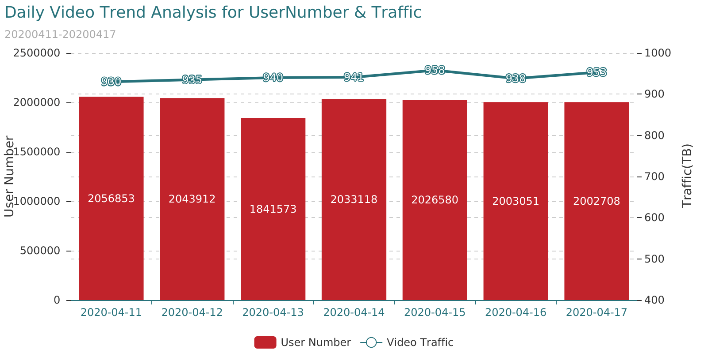

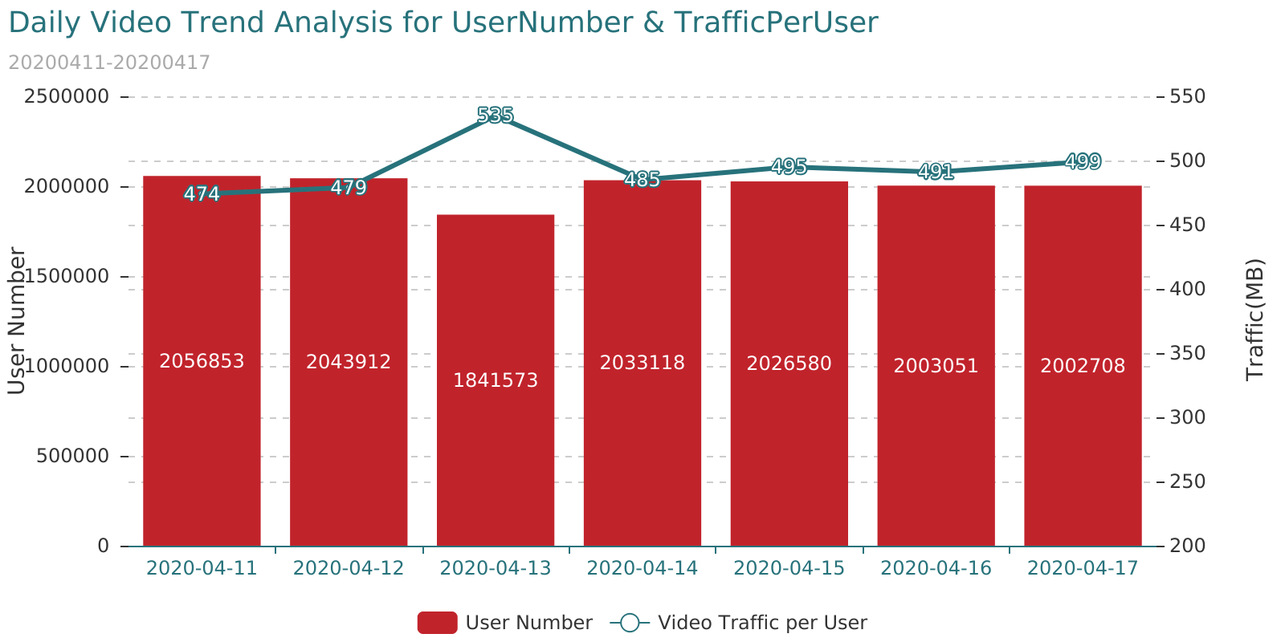

## 1.2 Hourly Video Application Trend Analysis

|  |  |  |  |
| --- | --- | --- | --- |
| DateTime | User Number | Traffic(TB) | Traffic per user (MB) |
| 20200416 00 | 312042 | 29.11 | 97.81 |
| 20200416 01 | 176389 | 19.83 | 117.86 |
| 20200416 02 | 105708 | 11.71 | 116.17 |
| 20200416 03 | 72277 | 7.22 | 104.68 |
| 20200416 04 | 70392 | 5.40 | 80.38 |
| 20200416 05 | 139176 | 7.07 | 53.26 |
| 20200416 06 | 314217 | 15.76 | 52.58 |
| 20200416 07 | 466897 | 26.06 | 58.53 |
| 20200416 08 | 599894 | 36.03 | 62.98 |
| 20200416 09 | 724051 | 45.00 | 65.17 |
| 20200416 10 | 788004 | 50.00 | 66.53 |
| 20200416 11 | 834625 | 53.23 | 66.87 |
| 20200416 12 | 890520 | 56.45 | 66.47 |
| 20200416 13 | 834931 | 57.17 | 71.8 |
| 20200416 14 | 806065 | 55.97 | 72.8 |
| 20200416 15 | 760046 | 53.12 | 73.29 |
| 20200416 16 | 742818 | 48.47 | 68.42 |
| 20200416 17 | 650420 | 42.62 | 68.71 |
| 20200416 18 | 707393 | 42.38 | 62.83 |
| 20200416 19 | 841596 | 48.97 | 61.01 |
| 20200416 20 | 992579 | 54.59 | 57.67 |
| 20200416 21 | 999238 | 61.48 | 64.52 |
| 20200416 22 | 814634 | 60.97 | 78.48 |
| 20200416 23 | 530205 | 48.94 | 96.79 |
| 20200417 00 | 310760 | 32.98 | 111.29 |
| 20200417 01 | 174591 | 19.65 | 118.0 |
| 20200417 02 | 102717 | 11.70 | 119.44 |
| 20200417 03 | 69657 | 7.25 | 109.1 |
| 20200417 04 | 68986 | 5.57 | 84.68 |
| 20200417 05 | 141381 | 7.25 | 53.74 |
| 20200417 06 | 314075 | 15.73 | 52.52 |
| 20200417 07 | 466122 | 26.02 | 58.54 |
| 20200417 08 | 605727 | 36.32 | 62.88 |
| 20200417 09 | 724961 | 45.48 | 65.78 |
| 20200417 10 | 803286 | 51.07 | 66.67 |
| 20200417 11 | 833660 | 53.28 | 67.02 |
| 20200417 12 | 882276 | 56.45 | 67.09 |
| 20200417 13 | 839249 | 55.44 | 69.26 |
| 20200417 14 | 803658 | 55.09 | 71.88 |
| 20200417 15 | 780498 | 53.46 | 71.82 |
| 20200417 16 | 765954 | 49.82 | 68.2 |
| 20200417 17 | 688552 | 45.23 | 68.88 |
| 20200417 18 | 729338 | 44.61 | 64.13 |
| 20200417 19 | 859357 | 51.80 | 63.2 |
| 20200417 20 | 1003594 | 57.98 | 60.58 |
| 20200417 21 | 987018 | 61.36 | 65.18 |
| 20200417 22 | 801539 | 61.03 | 79.84 |
| 20200417 23 | 512896 | 48.75 | 99.67 |

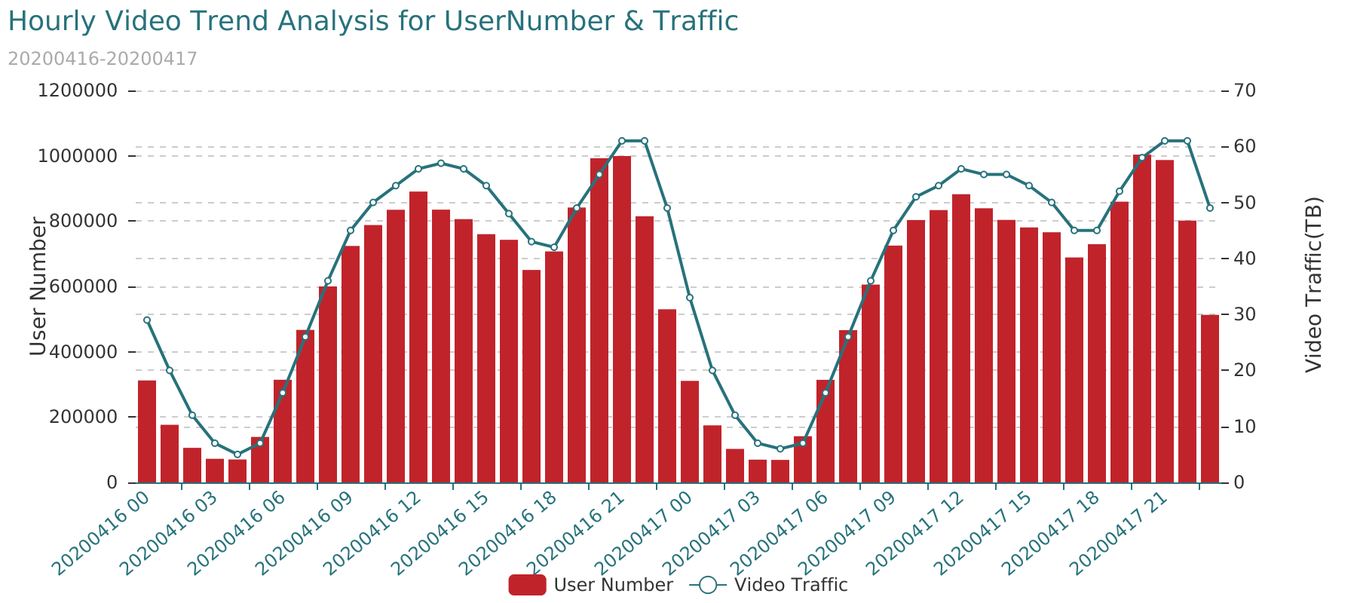

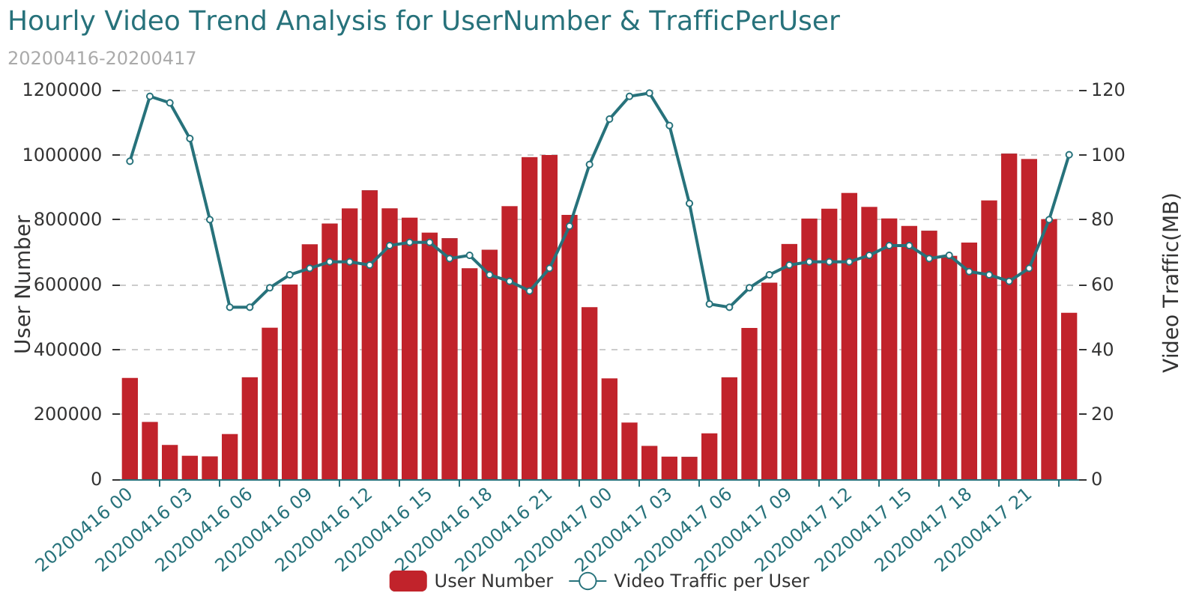

## 1.3 Video Application Trend for 3G/4G Traffic Analysis

|  |  |  |  |
| --- | --- | --- | --- |
| Date | RAT | Traffic(TB) | Traffic(MB) |
| 2020-04-11 | 4G | 802.92 | 841919298.36 |
| 2020-04-11 | 3G | 126.08 | 132201178.90 |
| 2020-04-12 | 4G | 805.92 | 845071223.34 |
| 2020-04-12 | 3G | 127.42 | 133605711.55 |
| 2020-04-13 | 4G | 811.35 | 850764145.32 |
| 2020-04-13 | 3G | 127.26 | 133441451.05 |
| 2020-04-14 | 3G | 127.55 | 133741944.49 |
| 2020-04-14 | 4G | 812.40 | 851858826.98 |
| 2020-04-15 | 3G | 128.75 | 135008849.91 |
| 2020-04-15 | 4G | 827.57 | 867768986.02 |
| 2020-04-16 | 3G | 126.17 | 132301672.88 |
| 2020-04-16 | 4G | 810.14 | 849492735.23 |
| 2020-04-17 | 4G | 824.36 | 864398879.99 |
| 2020-04-17 | 3G | 127.73 | 133935461.81 |

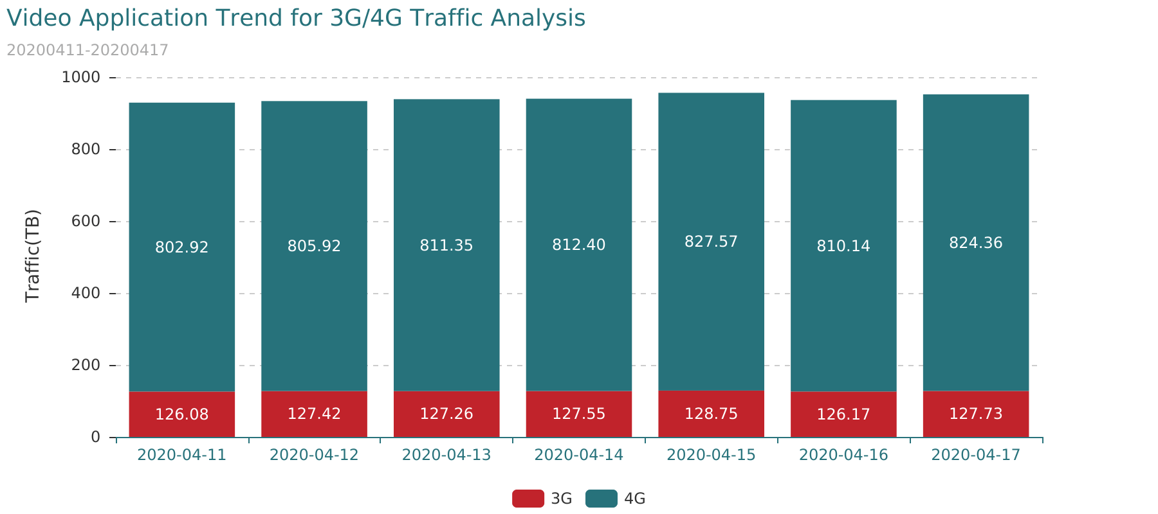

## 1.4 Application Traffic Ratio

|  |  |  |  |  |
| --- | --- | --- | --- | --- |
| Date | ServiceName | Traffic(GB) | Total Traffic(TB) | Ratio |
| 2020-04-17 | Video | 976195.41 | 1387.87 | 68.69 |
| 2020-04-17 | Web Browse | 256760.66 | 1387.87 | 18.07 |
| 2020-04-17 | Others | 68368.17 | 1387.87 | 4.81 |
| 2020-04-17 | VoIP | 40648.10 | 1387.87 | 2.86 |
| 2020-04-17 | App Stores | 31534.33 | 1387.87 | 2.22 |
| 2020-04-17 | Game | 29631.42 | 1387.87 | 2.08 |
| 2020-04-17 | Network Storage | 9734.55 | 1387.87 | 0.68 |
| 2020-04-17 | IM | 6019.05 | 1387.87 | 0.42 |
| 2020-04-17 | P2P | 1212.96 | 1387.87 | 0.09 |
| 2020-04-17 | Comm Traffic | 1071.46 | 1387.87 | 0.08 |

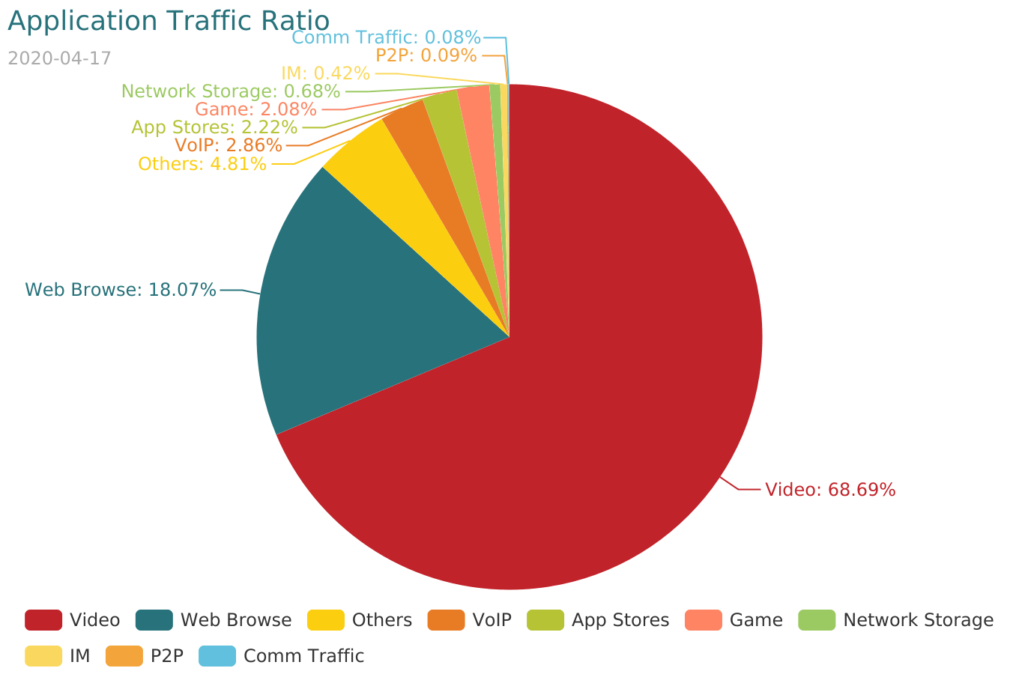

## 1.6 Video Application Traffic Ratio

|  |  |  |  |  |
| --- | --- | --- | --- | --- |
| Date | ServiceName | Traffic(GB) | Total Traffic(TB) | Ratio |
| 2020-04-17 | Video | 976195.41 | 1387.87 | 68.69 |
| 2020-04-17 | Web Browse | 256760.66 | 1387.87 | 18.07 |
| 2020-04-17 | Others | 68368.17 | 1387.87 | 4.81 |
| 2020-04-17 | VoIP | 40648.10 | 1387.87 | 2.86 |
| 2020-04-17 | App Stores | 31534.33 | 1387.87 | 2.22 |
| 2020-04-17 | Game | 29631.42 | 1387.87 | 2.08 |
| 2020-04-17 | Network Storage | 9734.55 | 1387.87 | 0.68 |
| 2020-04-17 | IM | 6019.05 | 1387.87 | 0.42 |
| 2020-04-17 | P2P | 1212.96 | 1387.87 | 0.09 |
| 2020-04-17 | Comm Traffic | 1071.46 | 1387.87 | 0.08 |

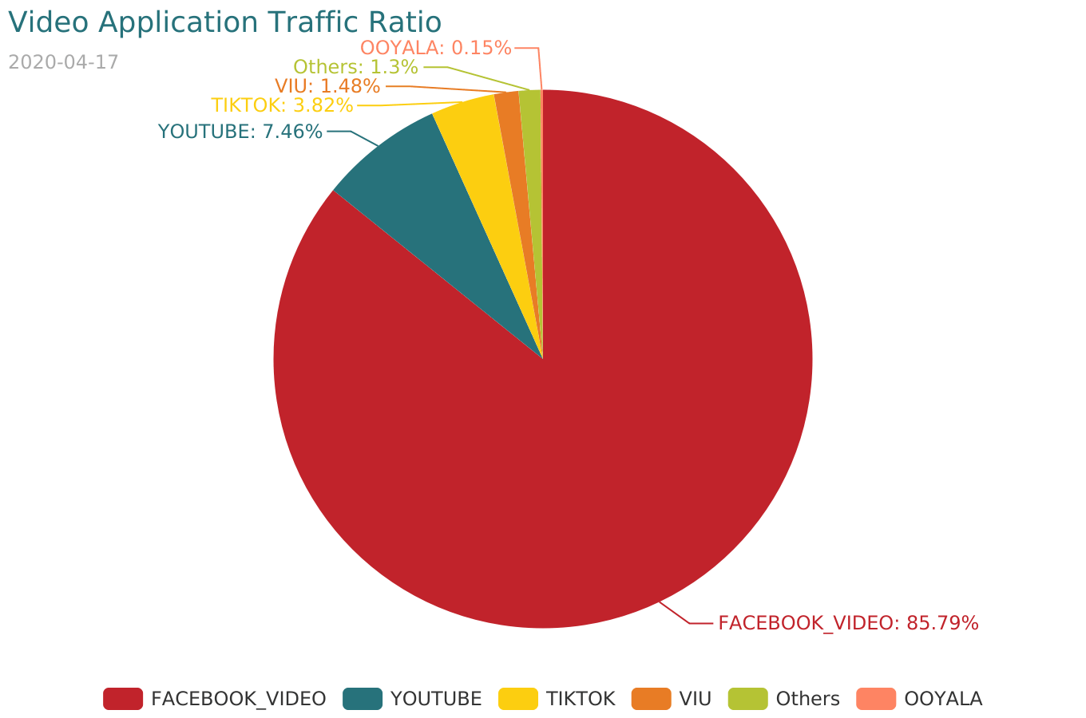

## 1.7 CDN of FACEBOOK-Video Trend Analysis

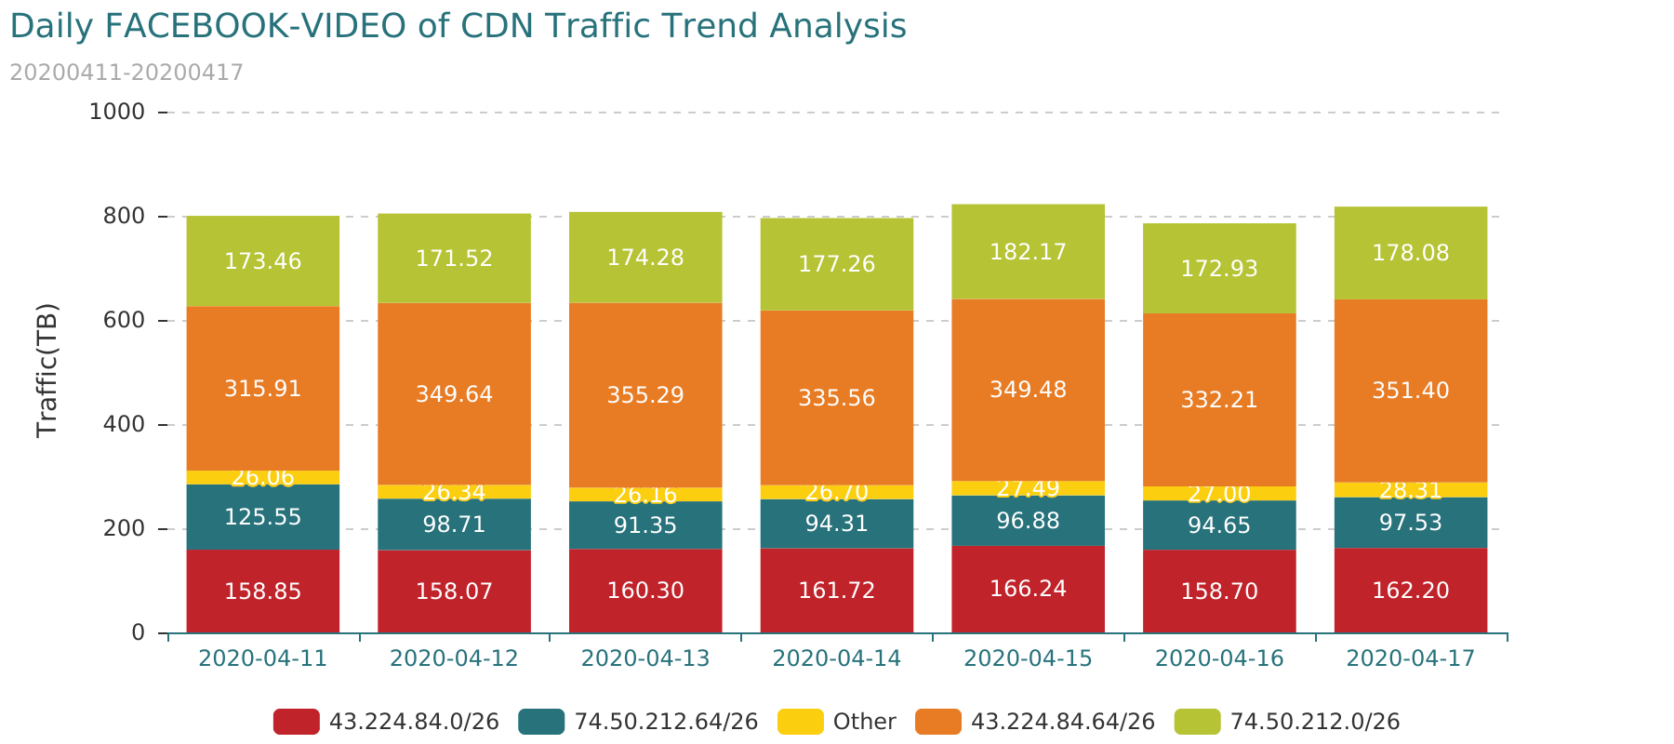

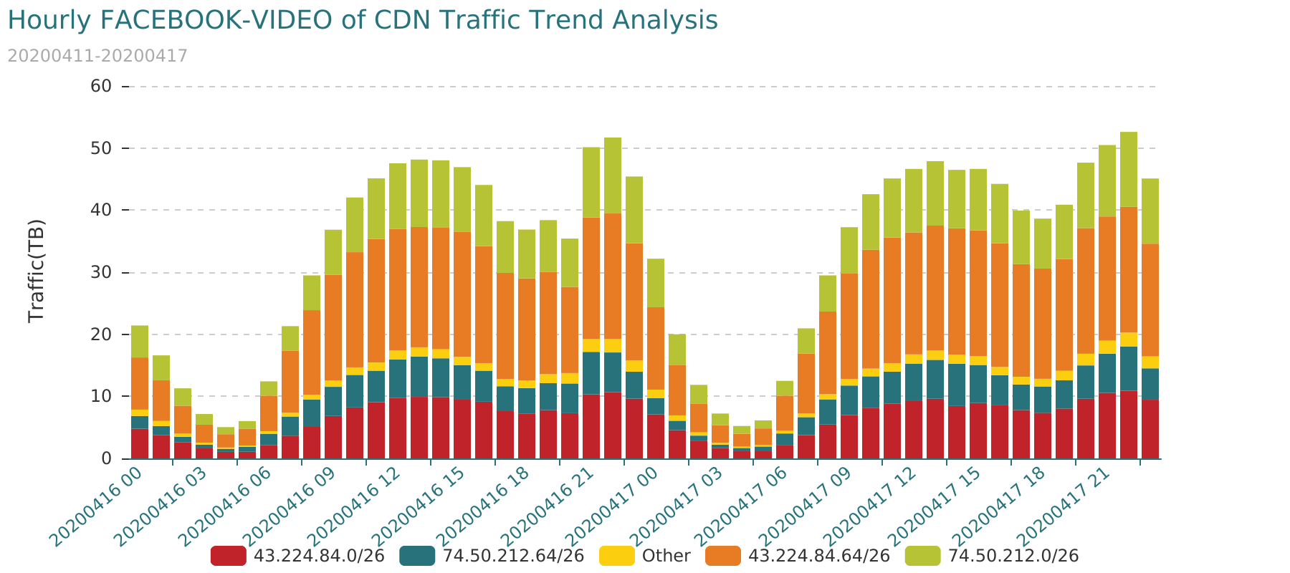

## 1.8 Video resolution Analysis

|  |  |  |  |  |  |  |  |
| --- | --- | --- | --- | --- | --- | --- | --- |
| Date | Video resolution | Traffic of Video Downloading(GB) | Successful Rate of Video Playing(%) | Stalling Frequency of Video Playing | Average Cache Duration of Video Playing(ms) | Valid Throughput of Video Download(Kbps) | Stalling Duration Ratio of Video Playing(%) |
| 2020-04-17 | 720P | 888138.1 | 91.96 | 11.95 | 2713.0 | 369.66 | 0.73 |
| 2020-04-17 | 360P | 9149.71 | 99.37 | 1.41 | 1220.0 | 737.12 | 5.36 |
| 2020-04-17 | 240 | 7521.23 | 99.64 | 1.15 | 1217.0 | 601.81 | 5.47 |
| 2020-04-17 | 480P | 6337.15 | 98.57 | 1.84 | 1439.0 | 822.91 | 5.13 |
| 2020-04-17 | <240P | 1459.03 | 99.82 | 1.0 | 1180.0 | 597.25 | 4.68 |
| 2020-04-17 | 1080P | 880.52 | 98.09 | 2.16 | 1456.0 | 1305.81 | 6.05 |
| 2020-04-17 | 2k | 53.31 | 91.86 | 4.63 | 2426.0 | 1533.7 | 5.83 |
| 2020-04-17 | >2K | 0.69 | 90.24 | 3.31 | 2643.0 | 714.45 | 6.52 |

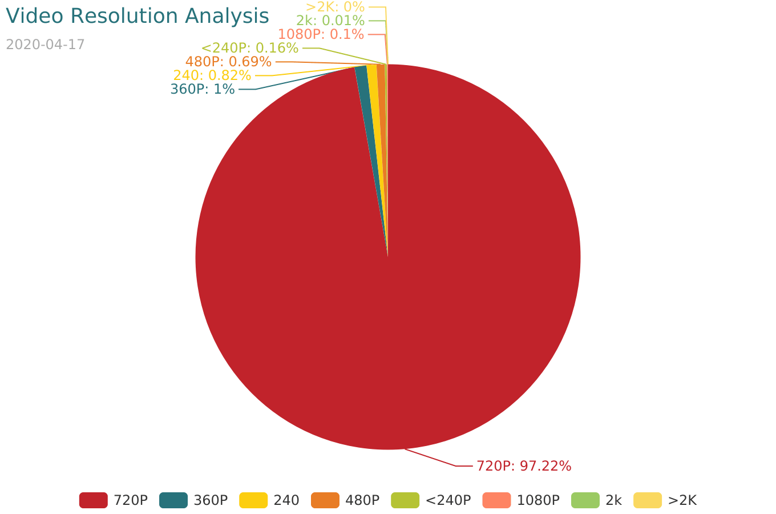

## 1.9 Attribution of Video Application Analysis

|  |  |  |
| --- | --- | --- |
| Date | CountryName | Total Traffic(GB) |
| 2020-04-11 | Myanmar | 851568.93 |
| 2020-04-11 | Singapore | 57429.61 |
| 2020-04-11 | Germany | 10809.49 |
| 2020-04-11 | U.S.A | 8089.42 |
| 2020-04-11 | China | 6094.63 |
| 2020-04-11 | Japan | 2046.58 |
| 2020-04-11 | Other | 7318.26 |

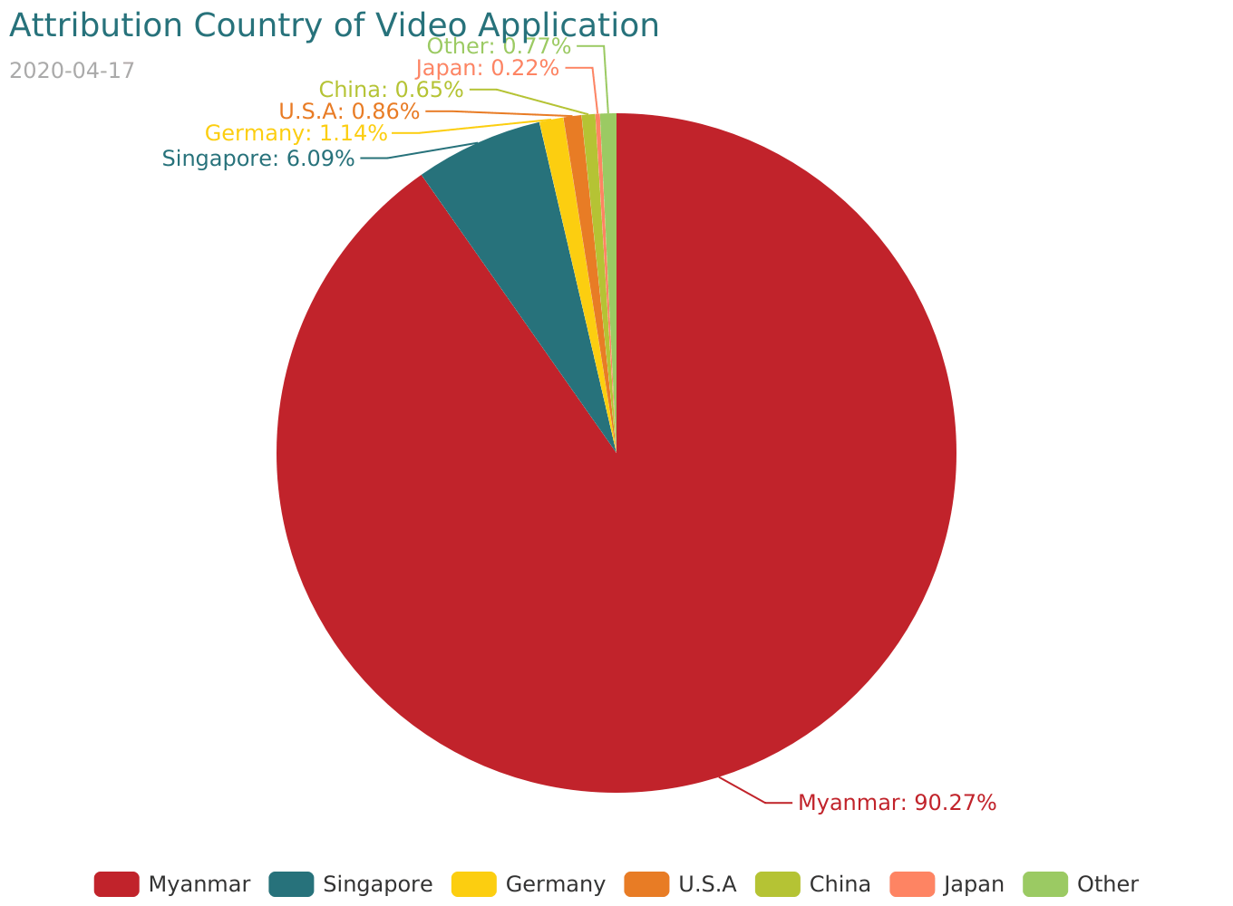

## 1.10 Video Application HotMap

The 4G_Video_Application_HotMap data for attachment<4G_Video_Application_HotMap.xlsx>

The 3G_Video_Application_HotMap data for attachment<3G_Video_Application_HotMap.xlsx>

# 2 Poor Quality Cell for Video Application

## 2.1 Poor Quality 4G-Cell for Video Application

* Condition1

"Traffic of Video Downloading (MB)" distribution information is as follows:

|  |  |  |  |  |  |  |
| --- | --- | --- | --- | --- | --- | --- |
| Indicator | MAX | MIN | Mode | Mean | Median | Standard |
| Traffic of Video Downloading (MB) | 371624.14 | 0.00 | 0.00 | 27351.09 | 12514.68 | 37695.98 |

|  |  |  |  |  |  |  |  |
| --- | --- | --- | --- | --- | --- | --- | --- |
| Indicator | 5th Percentile | 10th Percentile | 20th Percentile | 50th Percentile | 80th Percentile | 90th Percentile | 95th Percentile |
| Traffic of Video Downloading (MB) | 60.66 | 268.71 | 1233.6 | 12514.68 | 45610.4 | 77961.48 | 109104.81 |

Threshold: "Traffic of Video Downloading (MB)" > 60(MB)

* Condition2

Video indicator distribution information is as follows:

|  |  |  |  |  |  |  |
| --- | --- | --- | --- | --- | --- | --- |
| Indicator | MAX | MIN | Mode | Mean | Median | Standard |
| Successful Rate of Video Playing(%) | 100.00 | 25.00 | 100.00 | 93.35 | 94.12 | 3.58 |
| Average Cache Duration of Video Playing(ms) | 13540.50 | 0.00 | 0.00 | 2271.19 | 2041.53 | 940.7 |
| Stalling Frequency of Video Playing | 5.20 | 0.00 | 0.06 | 0.11 | 0.08 | 0.12 |
| Stalling Duration Ratio of Video Playing(%) | 32.03 | 0.00 | 0.83 | 1.21 | 0.92 | 1.13 |
| Average Delay of Downlink RTT(ms) | 476.52 | 0.00 | 10.73 | 17.34 | 14.35 | 11.35 |
| Valid Throughput of Video Download(Kbps) | 69047.14 | 168.79 | 3888.86 | 6827.37 | 5289.27 | 4677.98 |
| TCP Uplink Packet Lost Rate(%) | 2.18 | 0.00 | 0.01 | 0.02 | 0.01 | 0.04 |

|  |  |  |  |  |  |  |  |
| --- | --- | --- | --- | --- | --- | --- | --- |
| Indicator | 5th Percentile | 10th Percentile | 20th Percentile | 50th Percentile | 80th Percentile | 90th Percentile | 95th Percentile |
| Successful Rate of Video Playing(%) | 87.27 | 89.22 | 91.19 | 94.12 | 95.78 | 96.45 | 97.21 |
| Average Cache Duration of Video Playing(ms) | 1207.09 | 1344.69 | 1520.1 | 2041.53 | 2952.87 | 3555.88 | 4091.32 |
| Stalling Frequency of Video Playing | 0.03 | 0.04 | 0.05 | 0.08 | 0.14 | 0.21 | 0.3 |
| Stalling Duration Ratio of Video Playing(%) | 0.39 | 0.5 | 0.63 | 0.92 | 1.45 | 2.12 | 3.06 |
| Average Delay of Downlink RTT(ms) | 7.04 | 8.12 | 9.74 | 14.35 | 23.16 | 29.86 | 36.81 |
| Valid Throughput of Video Download(Kbps) | 1644.27 | 2167.67 | 3015.17 | 5289.27 | 10858.49 | 14009.55 | 16094.66 |
| TCP Uplink Packet Lost Rate(%) | 0.0 | 0.01 | 0.01 | 0.01 | 0.03 | 0.05 | 0.07 |

Threshold:

"Successful Rate of Video Playing(%)" < 87.0%

"Average Cache Duration of Video Playing(ms)" > 4091.0ms

"Stalling Frequency of Video Playing" > 0.3

"Stalling Duration Ratio of Video Playing(%)" > 3.06%

"Average Delay of Downlink RTT(ms)" > 37.0ms

"Valid Throughput of Video Download(Kbps)" < 1644.0Kbps

"TCP Uplink Packet Lost Rate(%)" > 0.07%

* Condition3

Poor-quality cell appear more than 6 times in 7 days.

* Condition4

Poor-quality cell has more than 3 indicator is bad in total 7 Indicator for 7 days.

There are 240 cells with poor video application quality for 7 days.

|  |  |
| --- | --- |
| vendor | Number |
| Nokia | 148 |
| ZTE | 81 |
| nan | 11 |

|  |  |
| --- | --- |
| project | Number |
| Bronze Area | 198 |
| Gold Area | 7 |
| Silver Area | 35 |

The poor-quality cell for attachment<Poor_Quality_4G-Cell_for_Video_Application.xlsx>

## 2.3 Poor Quality 3G-Cell for Video Application

* Condition1

"Traffic of Video Downloading (MB)" distribution information is as follows:

|  |  |  |  |  |  |  |
| --- | --- | --- | --- | --- | --- | --- |
| Indicator | MAX | MIN | Mode | Mean | Median | Standard |
| Traffic of Video Downloading (MB) | 41271.79 | 0.00 | 0.00 | 4032.15 | 2591.05 | 4316.01 |

|  |  |  |  |  |  |  |  |
| --- | --- | --- | --- | --- | --- | --- | --- |
| Indicator | 5th Percentile | 10th Percentile | 20th Percentile | 50th Percentile | 80th Percentile | 90th Percentile | 95th Percentile |
| Traffic of Video Downloading (MB) | 27.9 | 186.84 | 638.74 | 2591.03 | 6740.89 | 9973.05 | 13036.19 |

Threshold: "Traffic of Video Downloading (MB)" > 27(MB)

* Condition2

Video indicator distribution information is as follows:

|  |  |  |  |  |  |  |
| --- | --- | --- | --- | --- | --- | --- |
| Indicator | MAX | MIN | Mode | Mean | Median | Standard |
| Successful Rate of Video Playing(%) | 100.00 | 28.33 | 100.00 | 90.64 | 91.78 | 5.44 |
| Average Cache Duration of Video Playing(ms) | 29666.00 | 0.00 | 0.00 | 3133.48 | 2853.17 | 1284.13 |
| Stalling Frequency of Video Playing | 6.18 | 0.00 | 0.06 | 0.13 | 0.1 | 0.12 |
| Stalling Duration Ratio of Video Playing(%) | 42.21 | 0.00 | 0.00 | 1.32 | 1.07 | 1.07 |
| Average Delay of Downlink RTT(ms) | 2907.00 | 0.00 | 0.00 | 43.15 | 34.9 | 37.16 |
| Valid Throughput of Video Download(Kbps) | 39783.80 | 167.69 | 2469.34 | 5919.85 | 4662.31 | 3943.15 |
| TCP Uplink Packet Lost Rate(%) | 3.20 | 0.00 | 0.01 | 0.01 | 0.01 | 0.03 |

|  |  |  |  |  |  |  |  |
| --- | --- | --- | --- | --- | --- | --- | --- |
| Indicator | 5th Percentile | 10th Percentile | 20th Percentile | 50th Percentile | 80th Percentile | 90th Percentile | 95th Percentile |
| Successful Rate of Video Playing(%) | 80.08 | 84.36 | 87.7 | 91.78 | 94.38 | 95.65 | 96.88 |
| Average Cache Duration of Video Playing(ms) | 1618.83 | 1879.35 | 2179.9 | 2853.17 | 3926.91 | 4709.73 | 5766.35 |
| Stalling Frequency of Video Playing | 0.03 | 0.04 | 0.05 | 0.1 | 0.2 | 0.25 | 0.31 |
| Stalling Duration Ratio of Video Playing(%) | 0.3 | 0.43 | 0.58 | 1.07 | 1.93 | 2.41 | 2.94 |
| Average Delay of Downlink RTT(ms) | 17.95 | 20.72 | 24.68 | 34.9 | 51.17 | 68.29 | 95.98 |
| Valid Throughput of Video Download(Kbps) | 1555.32 | 2013.27 | 2572.97 | 4662.31 | 9271.01 | 11496.42 | 13398.01 |
| TCP Uplink Packet Lost Rate(%) | 0.0 | 0.0 | 0.01 | 0.01 | 0.02 | 0.03 | 0.03 |

Threshold:

"Successful Rate of Video Playing(%)" < 80.0%

"Average Cache Duration of Video Playing(ms)" > 5766.0ms

"Stalling Frequency of Video Playing" > 0.31

"Stalling Duration Ratio of Video Playing(%)" > 2.94%

"Average Delay of Downlink RTT(ms)" > 96.0ms

"Valid Throughput of Video Download(Kbps)" < 1555.0Kbps

"TCP Uplink Packet Lost Rate(%)" > 0.03%

* Condition3

Poor-quality cell appear more than 6 times in 7 days.

* Condition4

Poor-quality cell has more than 3 indicator is bad in total 7 Indicator for 7 days.

There are 350 cells with poor video application quality for 7 days.

|  |  |
| --- | --- |
| vendor | Number |
| Nokia | 302 |
| ZTE | 46 |
| nan | 2 |

|  |  |
| --- | --- |
| project | Number |
| Bronze Area | 184 |
| Gold Area | 102 |
| Silver Area | 64 |

The poor-quality cell for attachment<Poor_Quality_3G-Cell_for_Video_Application.xlsx>

# 3 Poor Quality SP for Video Application

## 3.1 Poor Quality SP for Video Application

* Condition1

"Total Traffic(MB)" distribution information is as follows:

|  |  |  |  |  |  |  |
| --- | --- | --- | --- | --- | --- | --- |
| Indicator | MAX | MIN | Mode | Mean | Median | Standard |
| Total Traffic(MB) | 324025213.71 | 0.02 | 0.03 | 19310.46 | 4.48 | 1864218.58 |

|  |  |  |  |  |  |  |  |
| --- | --- | --- | --- | --- | --- | --- | --- |
| Indicator | 5th Percentile | 10th Percentile | 20th Percentile | 50th Percentile | 80th Percentile | 90th Percentile | 95th Percentile |
| Total Traffic(MB) | 0.04 | 0.06 | 0.15 | 4.48 | 88.22 | 395.41 | 1443.86 |

Threshold: "Total Traffic(MB)" > 512(MB)

* Condition2

Video indicator distribution information is as follows:

|  |  |  |  |  |  |  |
| --- | --- | --- | --- | --- | --- | --- |
| Indicator | MAX | MIN | Mode | Mean | Median | Standard |
| Successful Rate of Video Playing(%) | 100.00 | 0.00 | 100.00 | 94.5 | 98.85 | 11.81 |
| Average Cache Duration of Video Playing(ms) | 29968.00 | 0.00 | 0.00 | 3927.04 | 3054.45 | 2870.58 |
| Stalling Frequency of Video Playing | 3.60 | 0.00 | 0.00 | 0.33 | 0.23 | 0.34 |
| Stalling Duration Ratio of Video Playing(%) | 64.66 | 0.00 | 0.00 | 3.24 | 2.11 | 3.44 |
| Valid Throughput of Video Download(Kbps) | 167493.55 | 0.00 | 0.00 | 6825.49 | 5612.22 | 6141.08 |

|  |  |  |  |  |  |  |  |
| --- | --- | --- | --- | --- | --- | --- | --- |
| Indicator | 5th Percentile | 10th Percentile | 20th Percentile | 50th Percentile | 80th Percentile | 90th Percentile | 95th Percentile |
| Successful Rate of Video Playing(%) | 72.35 | 82.98 | 93.33 | 98.85 | 100.0 | 100.0 | 100.0 |
| Average Cache Duration of Video Playing(ms) | 929.62 | 1123.55 | 1547.43 | 3054.22 | 6143.97 | 7930.51 | 9294.11 |
| Stalling Frequency of Video Playing | 0.0 | 0.01 | 0.06 | 0.23 | 0.54 | 0.73 | 0.93 |
| Stalling Duration Ratio of Video Playing(%) | 0.0 | 0.04 | 0.59 | 2.11 | 5.98 | 7.19 | 8.71 |
| Valid Throughput of Video Download(Kbps) | 995.18 | 1884.95 | 3031.03 | 5612.18 | 9187.53 | 12017.81 | 16269.57 |

Threshold:

"Successful Rate of Video Playing(%)" < 83.0%

"Average Cache Duration of Video Playing(ms)" > 7931.0ms

"Stalling Frequency of Video Playing" > 0.73

"Stalling Duration Ratio of Video Playing(%)" > 7.19%

"Valid Throughput of Video Download(Kbps)" < 1885.0Kbps

* Condition3

Poor-quality server_ip appear more than 4 times in 7 days.

* Condition4

Poor-quality server_ip has more than 2 indicator is bad in total 5 Indicator for 7 days.

"7day Traffic Traffic(MB)" distribution information is as follows:

|  |  |
| --- | --- |
| country_name | number |
| China | 15 |
| France | 1 |
| Germany | 7 |
| Japan | 3 |
| Netherlands | 4 |
| Singapore | 6 |
| Thailand | 2 |
| U.S.A | 6 |

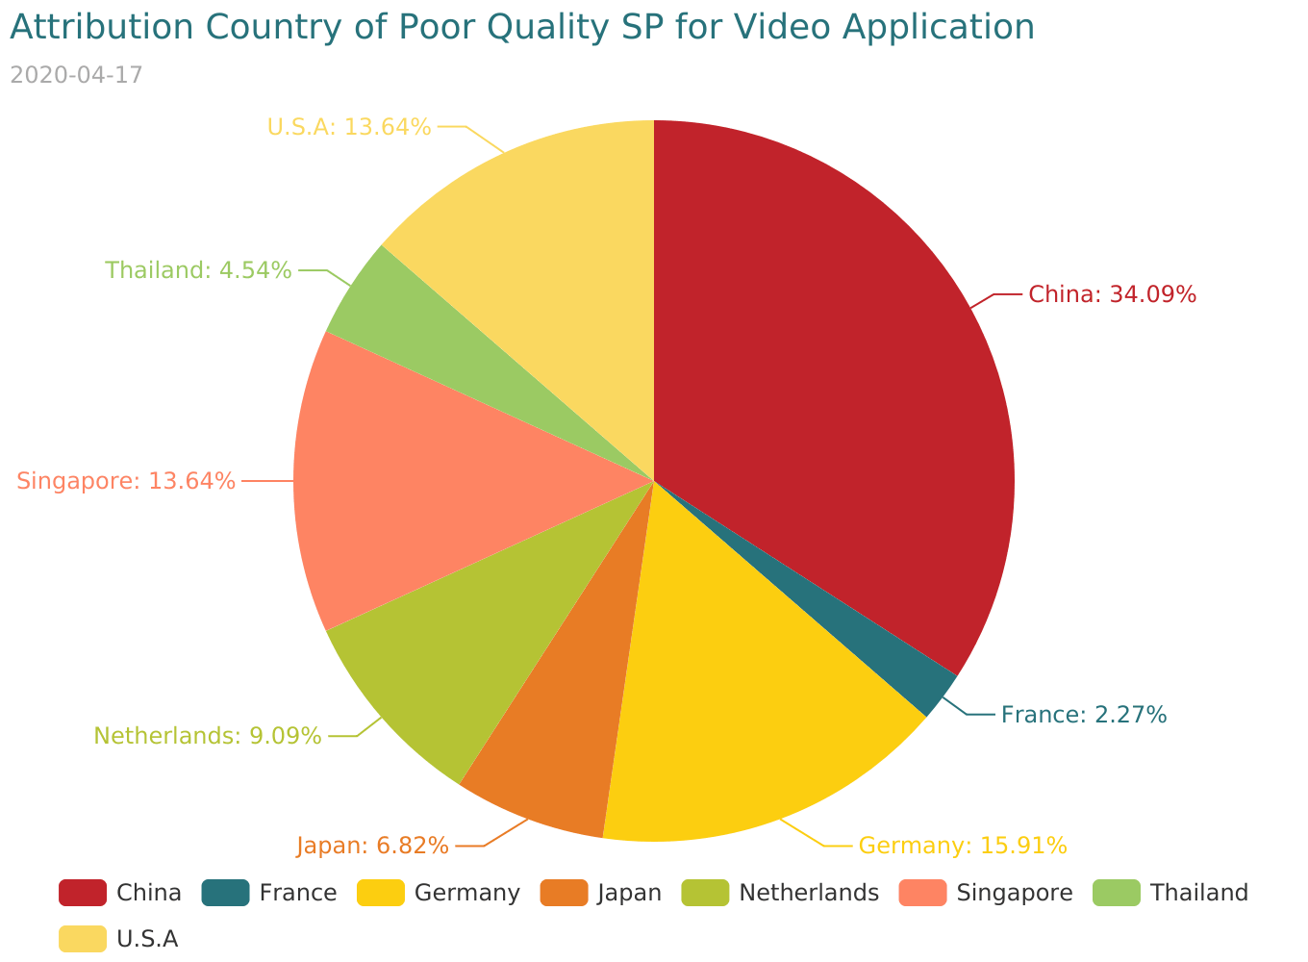

|  |  |  |
| --- | --- | --- |
| segment | number | 7day Traffic Traffic(MB) |
| 139.5.108.* | 15 | 458347.22 |
| 79.137.64.* | 1 | 5208.75 |
| 89.255.250.* | 7 | 96667.7 |
| 150.109.206.* | 3 | 36016.590000000004 |
| 89.255.248.* | 4 | 13861.25 |
| 139.99.123.* | 6 | 116363.17 |
| 107.155.27.* | 2 | 21579.620000000003 |
| 104.18.36.* | 6 | 23955.83 |

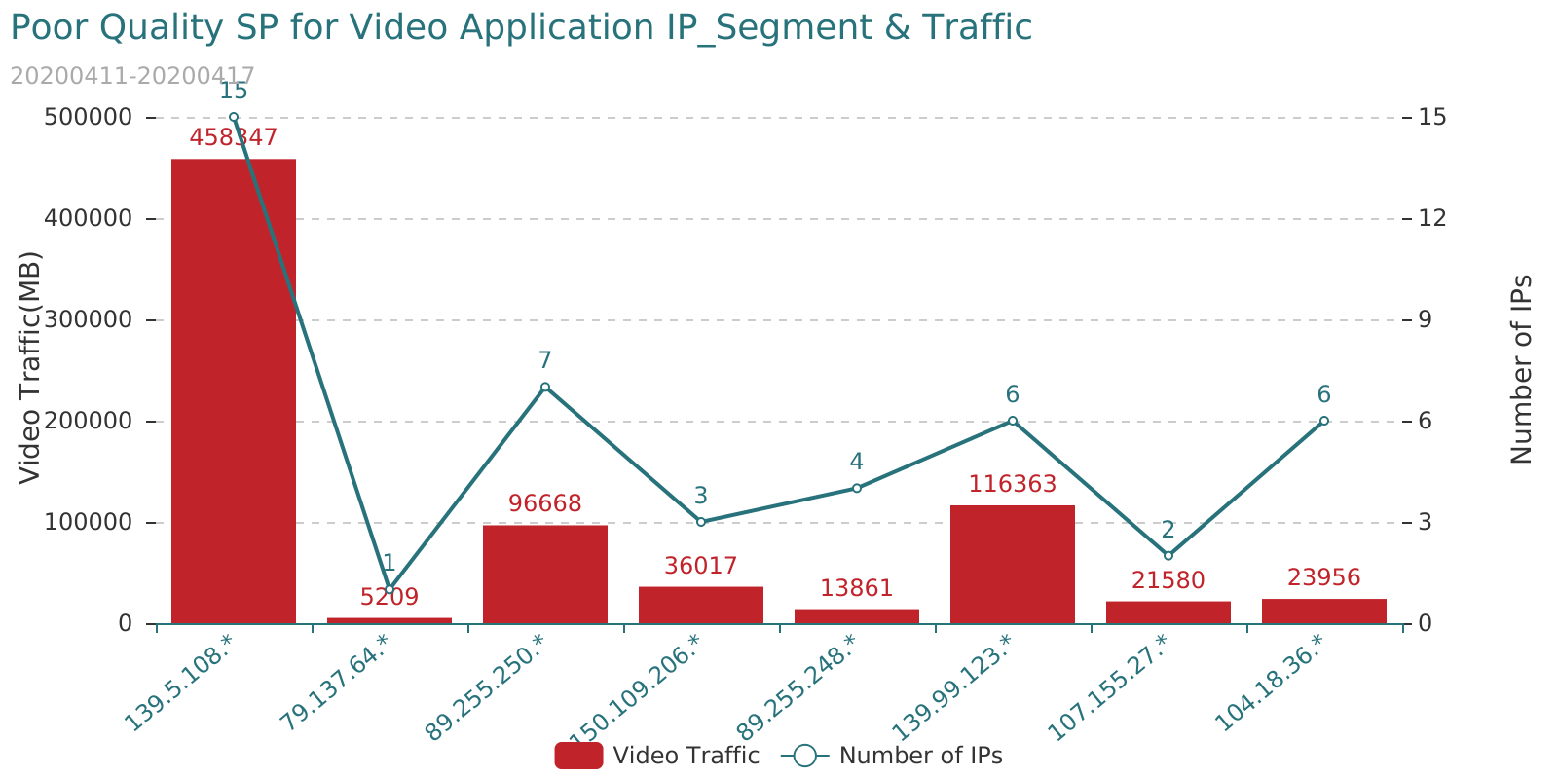

The poor-quality SP for attachment<Poor_Quality_SP_for_Video_Application.xlsx>

## 3.2 Poor Quality CDN SP for FACEBOOK-Video Application

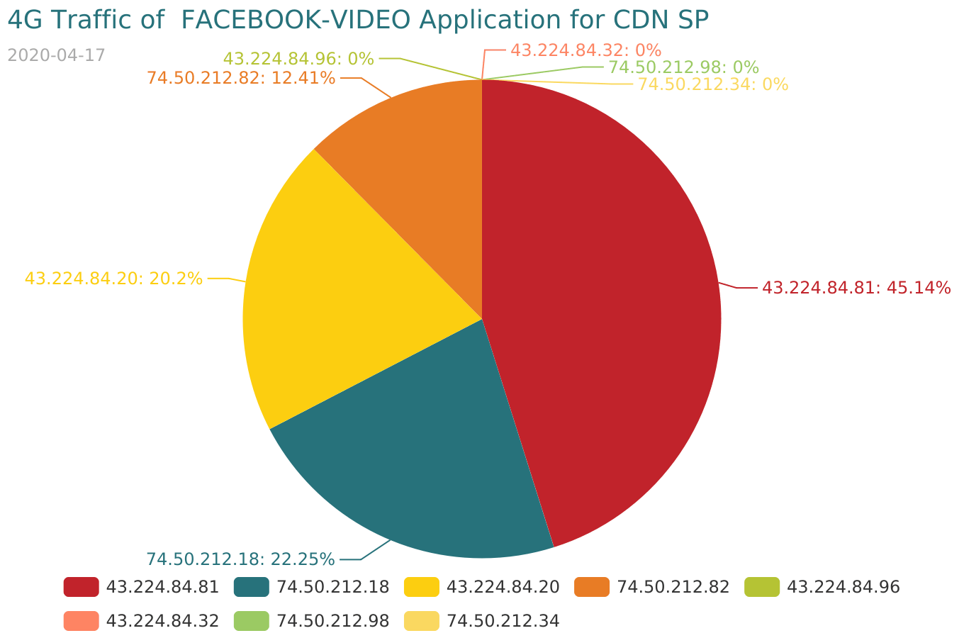

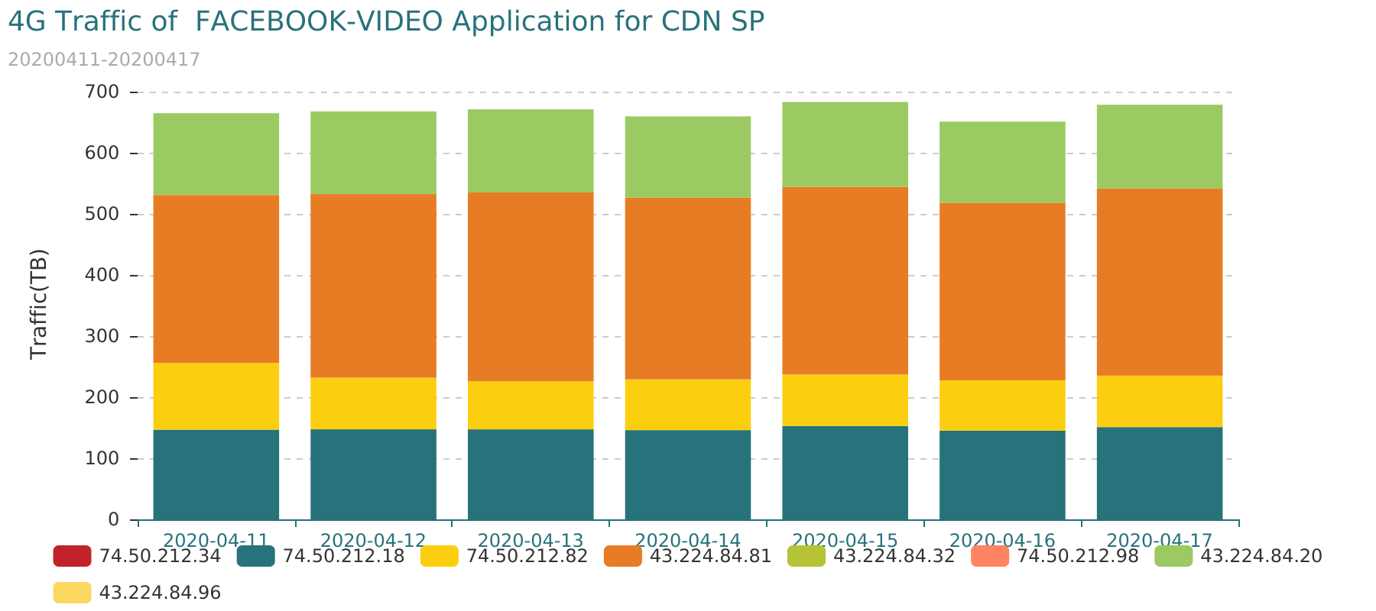

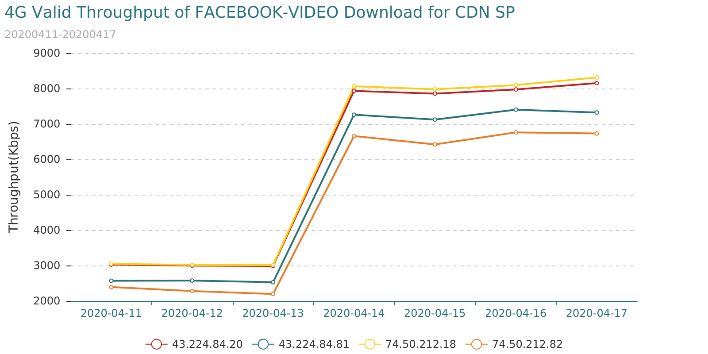

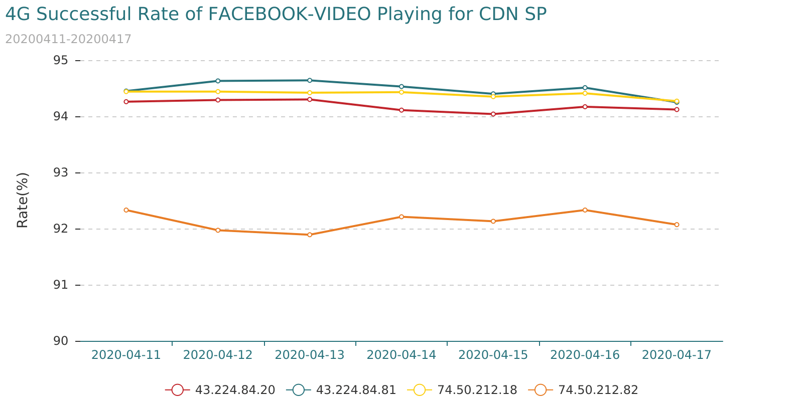

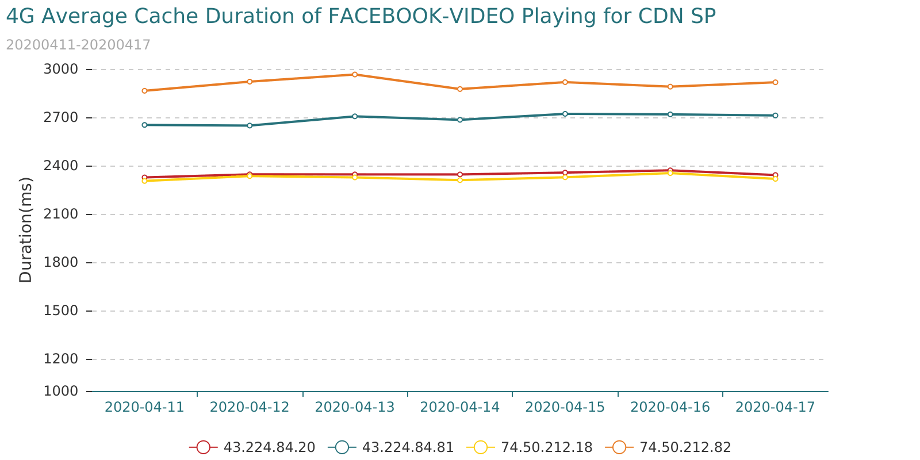

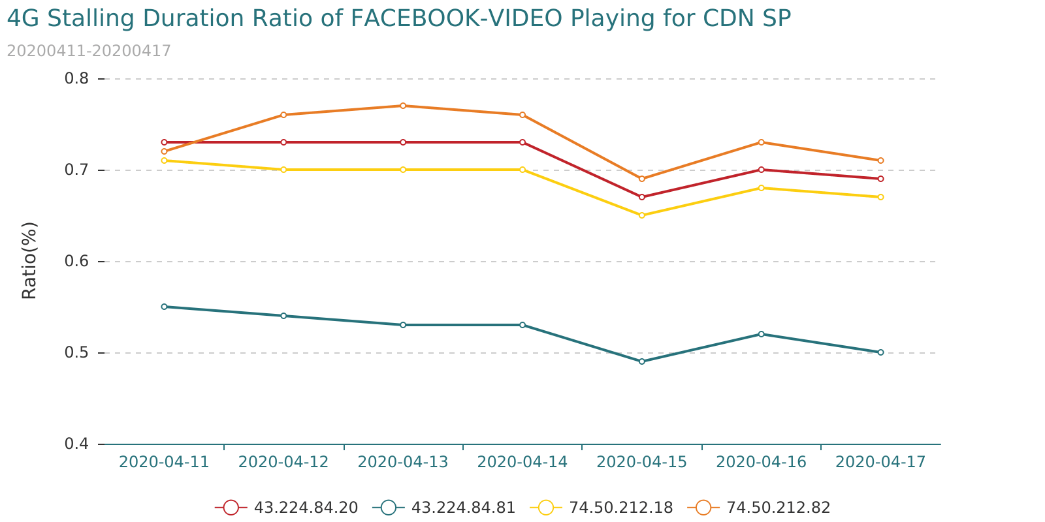

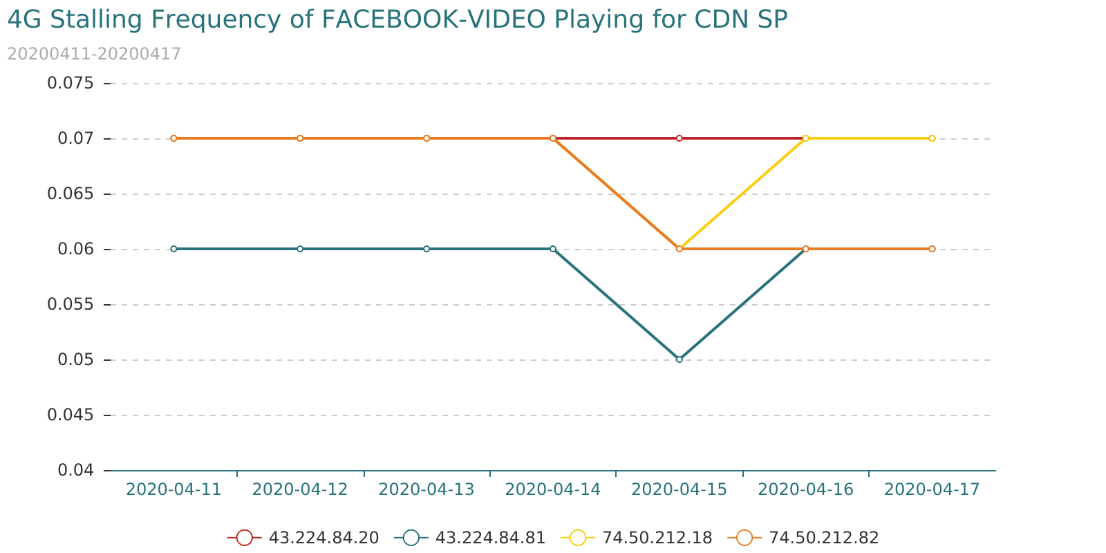

## 3.3 Poor Quality Non-CDN SP for FACEBOOK-Video Application

* Condition1

"Total Traffic(MB)" distribution information is as follows:

|  |  |  |  |  |  |  |
| --- | --- | --- | --- | --- | --- | --- |
| Indicator | MAX | MIN | Mode | Mean | Median | Standard |
| Total Traffic(MB) | 20294166.54 | 0.02 | 0.07 | 27282.67 | 11.21 | 540329.37 |

|  |  |  |  |  |  |  |  |
| --- | --- | --- | --- | --- | --- | --- | --- |
| Indicator | 5th Percentile | 10th Percentile | 20th Percentile | 50th Percentile | 80th Percentile | 90th Percentile | 95th Percentile |
| Total Traffic(MB) | 0.13 | 0.38 | 1.24 | 11.21 | 134.02 | 455.65 | 2112.44 |

Threshold: "Total Traffic(MB)" > 100(MB)

* Condition2

Video indicator distribution information is as follows:

|  |  |  |  |  |  |  |
| --- | --- | --- | --- | --- | --- | --- |
| Indicator | MAX | MIN | Mode | Mean | Median | Standard |
| Successful Rate of Video Playing(%) | 100.00 | 0.00 | 100.00 | 84.17 | 85.25 | 10.16 |
| Average Cache Duration of Video Playing(ms) | 26205.00 | 0.00 | 0.00 | 3221.5 | 3314.41 | 1657.67 |
| Stalling Frequency of Video Playing | 1.96 | 0.00 | 0.00 | 0.09 | 0.07 | 0.11 |
| Stalling Duration Ratio of Video Playing(%) | 14.20 | 0.00 | 0.00 | 1.09 | 0.8 | 1.18 |
| Valid Throughput of Video Download(Kbps) | 48020.31 | 0.00 | 1365.31 | 5008.57 | 4449.77 | 4200.19 |

|  |  |  |  |  |  |  |  |
| --- | --- | --- | --- | --- | --- | --- | --- |
| Indicator | 5th Percentile | 10th Percentile | 20th Percentile | 50th Percentile | 80th Percentile | 90th Percentile | 95th Percentile |
| Successful Rate of Video Playing(%) | 65.03 | 70.9 | 76.03 | 85.25 | 91.43 | 100.0 | 100.0 |
| Average Cache Duration of Video Playing(ms) | 414.5 | 1287.16 | 1857.74 | 3310.94 | 4356.64 | 4762.78 | 5187.21 |
| Stalling Frequency of Video Playing | 0.0 | 0.0 | 0.03 | 0.07 | 0.12 | 0.15 | 0.21 |
| Stalling Duration Ratio of Video Playing(%) | 0.0 | 0.02 | 0.37 | 0.8 | 1.52 | 2.32 | 3.32 |
| Valid Throughput of Video Download(Kbps) | 1300.59 | 1494.7 | 1920.86 | 4449.48 | 6454.07 | 8436.28 | 11849.12 |

Threshold:

"Successful Rate of Video Playing(%)" < 71.0%

"Average Cache Duration of Video Playing(ms)" > 4763.0ms

"Stalling Frequency of Video Playing" > 0.15

"Stalling Duration Ratio of Video Playing(%)" > 2.32%

"Valid Throughput of Video Download(Kbps)" < 1495.0Kbps

* Condition3

Poor-quality server_ip appear more than 4 times in 7 days.

* Condition4

Poor-quality server_ip has more than 1 indicator is bad in total 5 Indicator for 7 days.

"7day Traffic Traffic(MB)" distribution information is as follows:

|  |  |
| --- | --- |
| country_name | number |
| China | 1 |
| Nepal | 1 |
| The United Arab Emirates | 4 |
| U.S.A | 5 |
| Vietnam? | 4 |

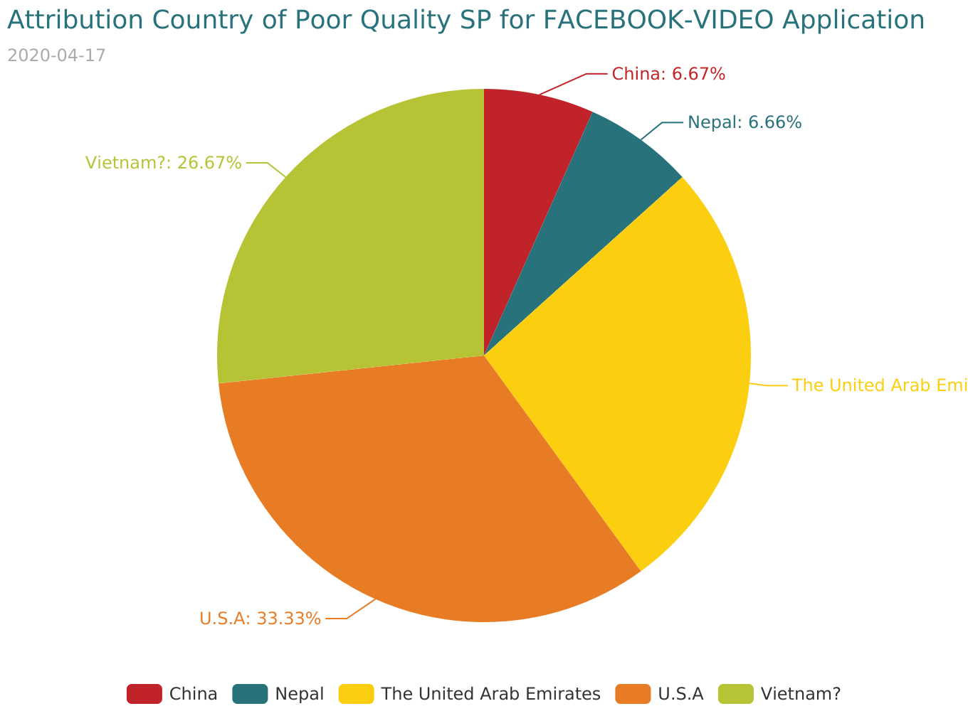

|  |  |  |
| --- | --- | --- |
| segment | number | 7day Traffic Traffic(MB) |
| 157.240.15.* | 1 | 2654.19 |
| 120.89.99.* | 1 | 1062.32 |
| 157.240.162.* | 4 | 14035.98 |
| 157.240.11.* | 5 | 241062.82 |
| 183.80.129.* | 4 | 13667.99 |

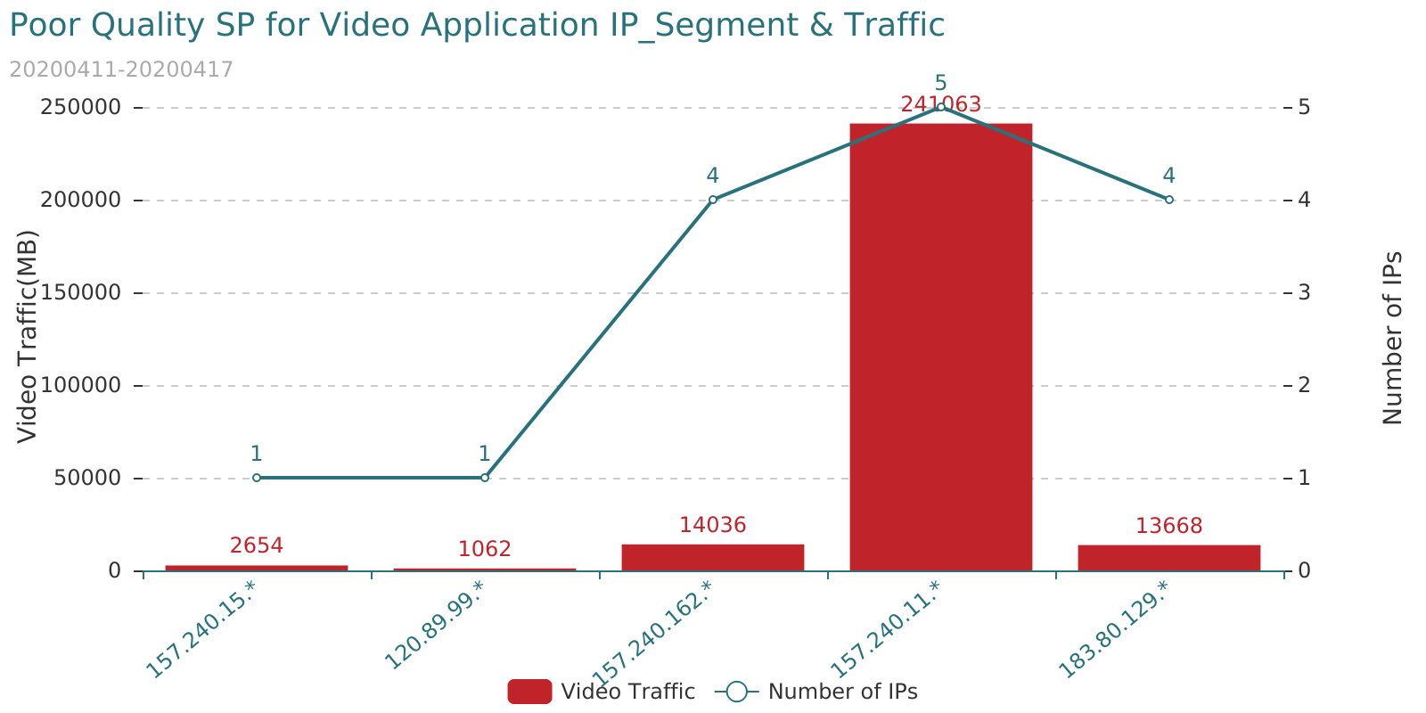

The poor-quality SP for attachment<Poor_Quality_SP_for_FACEBOOK-VIDEO_Application.xlsx>

# 4 Poor Quality User for Video Application

## 4.1 Poor Quality 4G-User for Video Application

* Condition1

"Traffic of Video Downloading (MB)" distribution information is as follows:

|  |  |  |  |  |  |  |
| --- | --- | --- | --- | --- | --- | --- |
| Indicator | MAX | MIN | Mode | Mean | Median | Standard |
| Traffic of Video Downloading (MB) | 69244.09 | 50.00 | 50.43 | 629.35 | 363.74 | 876.3 |

|  |  |  |  |  |  |  |  |
| --- | --- | --- | --- | --- | --- | --- | --- |
| Indicator | 5th Percentile | 10th Percentile | 20th Percentile | 50th Percentile | 80th Percentile | 90th Percentile | 95th Percentile |
| Traffic of Video Downloading (MB) | 68.06 | 88.57 | 137.44 | 363.74 | 889.73 | 1387.37 | 2019.71 |

Threshold: "Traffic of Video Downloading (MB)" > 50(MB)

* Condition2

Video indicator distribution information is as follows:

|  |  |  |  |  |  |  |
| --- | --- | --- | --- | --- | --- | --- |
| Indicator | MAX | MIN | Mode | Mean | Median | Standard |
| Successful Rate of Video Playing(%) | 100.00 | 3.33 | 100.00 | 93.81 | 95.24 | 6.52 |
| Average Cache Duration of Video Playing(ms) | 29976.00 | 0.00 | 0.00 | 2413.17 | 2069.7 | 1583.89 |
| Stalling Frequency of Video Playing | 16.63 | 0.00 | 0.00 | 0.09 | 0.05 | 0.16 |
| Stalling Duration Ratio of Video Playing(%) | 405.46 | 0.00 | 0.00 | 1.03 | 0.57 | 1.55 |
| Average Delay of RTT(ms) | 11385.00 | 0.00 | 0.00 | 24.33 | 17.57 | 29.24 |
| Valid Throughput of Video Download(Kbps) | 11499919.78 | 35.54 | 3637.54 | 7575.41 | 5111.67 | 7860.39 |
| TCP Packet Lost Rate(%) | 32.03 | 0.00 | 0.00 | 0.19 | 0.02 | 0.55 |

|  |  |  |  |  |  |  |  |
| --- | --- | --- | --- | --- | --- | --- | --- |
| Indicator | 5th Percentile | 10th Percentile | 20th Percentile | 50th Percentile | 80th Percentile | 90th Percentile | 95th Percentile |
| Successful Rate of Video Playing(%) | 81.4 | 85.71 | 89.47 | 95.24 | 100.0 | 100.0 | 100.0 |
| Average Cache Duration of Video Playing(ms) | 523.9 | 760.52 | 1124.95 | 2069.7 | 3516.69 | 4501.5 | 5426.09 |
| Stalling Frequency of Video Playing | 0.0 | 0.0 | 0.0 | 0.05 | 0.15 | 0.23 | 0.34 |
| Stalling Duration Ratio of Video Playing(%) | 0.0 | 0.0 | 0.0 | 0.57 | 1.63 | 2.52 | 3.58 |
| Average Delay of RTT(ms) | 5.61 | 7.31 | 9.89 | 17.57 | 32.98 | 46.57 | 62.59 |
| Valid Throughput of Video Download(Kbps) | 1196.71 | 1705.66 | 2513.29 | 5111.67 | 12048.13 | 17194.68 | 21937.38 |
| TCP Packet Lost Rate(%) | 0.0 | 0.0 | 0.0 | 0.02 | 0.17 | 0.43 | 0.93 |

Threshold:

"Successful Rate of Video Playing(%)" < 81.0%

"Average Cache Duration of Video Playing(ms)" > 5426.0ms

"Stalling Frequency of Video Playing" > 0.34

"Stalling Duration Ratio of Video Playing(%)" > 3.58%

"Average Delay of RTT(ms)" > 63.0ms

"Valid Throughput of Video Download(Kbps)" < 1197.0Kbps

"TCP Packet Lost Rate(%)" > 0.93%

* Condition3

Poor-quality cell appear more than 5 times in 7 days.

* Condition4

Poor-quality cell has more than 3 indicator is bad in total 7 Indicator for 7 days.

There are 199 users with poor video application quality for 7 days.

|  |  |
| --- | --- |
| userconsumptionlevel_name | Number |
| Bronze | 95 |
| Gold | 65 |
| Silver | 39 |

The poor-quality imsi for attachment<Poor_Quality_4G-Users_for_Video_Application.xlsx>

## 4.2 Poor Quality 3G-User for Video Application

* Condition1

"Traffic of Video Downloading (MB)" distribution information is as follows:

|  |  |  |  |  |  |  |
| --- | --- | --- | --- | --- | --- | --- |
| Indicator | MAX | MIN | Mode | Mean | Median | Standard |
| Traffic of Video Downloading (MB) | 35261.93 | 50.00 | 51.07 | 335.8 | 199.09 | 473.4 |

|  |  |  |  |  |  |  |  |
| --- | --- | --- | --- | --- | --- | --- | --- |
| Indicator | 5th Percentile | 10th Percentile | 20th Percentile | 50th Percentile | 80th Percentile | 90th Percentile | 95th Percentile |
| Traffic of Video Downloading (MB) | 58.14 | 67.35 | 89.55 | 199.09 | 470.44 | 714.3 | 1002.6 |

Threshold: "Traffic of Video Downloading (MB)" > 30(MB)

* Condition2

Video indicator distribution information is as follows:

|  |  |  |  |  |  |  |
| --- | --- | --- | --- | --- | --- | --- |
| Indicator | MAX | MIN | Mode | Mean | Median | Standard |
| Successful Rate of Video Playing(%) | 100.00 | 4.76 | 100.00 | 91.99 | 93.75 | 8.33 |
| Average Cache Duration of Video Playing(ms) | 29969.00 | 0.00 | 0.00 | 3410.26 | 3042.0 | 2060.17 |
| Stalling Frequency of Video Playing | 18.18 | 0.00 | 0.00 | 0.15 | 0.07 | 0.26 |
| Stalling Duration Ratio of Video Playing(%) | 60.92 | 0.00 | 0.00 | 1.43 | 0.71 | 2.14 |
| Average Delay of RTT(ms) | 17506.00 | 0.00 | 0.00 | 45.33 | 34.0 | 47.76 |
| Valid Throughput of Video Download(Kbps) | 71446.45 | 47.63 | 2560.36 | 6247.52 | 4000.69 | 5498.41 |
| TCP Packet Lost Rate(%) | 14.28 | 0.00 | 0.00 | 0.05 | 0.01 | 0.18 |

|  |  |  |  |  |  |  |  |
| --- | --- | --- | --- | --- | --- | --- | --- |
| Indicator | 5th Percentile | 10th Percentile | 20th Percentile | 50th Percentile | 80th Percentile | 90th Percentile | 95th Percentile |
| Successful Rate of Video Playing(%) | 75.86 | 81.0 | 86.21 | 93.75 | 100.0 | 100.0 | 100.0 |
| Average Cache Duration of Video Playing(ms) | 788.24 | 1155.5 | 1706.22 | 3042.0 | 4906.0 | 6086.71 | 7180.16 |
| Stalling Frequency of Video Playing | 0.0 | 0.0 | 0.0 | 0.07 | 0.23 | 0.39 | 0.58 |
| Stalling Duration Ratio of Video Playing(%) | 0.0 | 0.0 | 0.0 | 0.71 | 2.29 | 3.7 | 5.34 |
| Average Delay of RTT(ms) | 13.53 | 16.84 | 21.46 | 34.0 | 58.77 | 81.94 | 111.53 |
| Valid Throughput of Video Download(Kbps) | 1122.09 | 1537.87 | 2164.21 | 4000.69 | 10350.69 | 14523.23 | 17766.87 |
| TCP Packet Lost Rate(%) | 0.0 | 0.0 | 0.0 | 0.01 | 0.06 | 0.12 | 0.2 |

Threshold:

"Successful Rate of Video Playing(%)" < 76.0%

"Average Cache Duration of Video Playing(ms)" > 7180.0ms

"Stalling Frequency of Video Playing" > 0.58

"Stalling Duration Ratio of Video Playing(%)" > 5.34%

"Average Delay of RTT(ms)" > 112.0ms

"Valid Throughput of Video Download(Kbps)" < 1122.0Kbps

"TCP Packet Lost Rate(%)" > 0.2%

* Condition3

Poor-quality cell appear more than 5 times in 7 days.

* Condition4

Poor-quality cell has more than 2 indicator is bad in total 7 Indicator for 7 days.

There are 231 users with poor video application quality for 7 days.

|  |  |
| --- | --- |
| userconsumptionlevel_name | Number |
| Bronze | 201 |
| Gold | 18 |
| Silver | 12 |

The poor-quality imsi for attachment<Poor_Quality_3G-Users_for_Video_Application.xlsx>

# 5 APN-Server Quality for Video Application

## 5.1 4G APN-Server Quality for Video Application

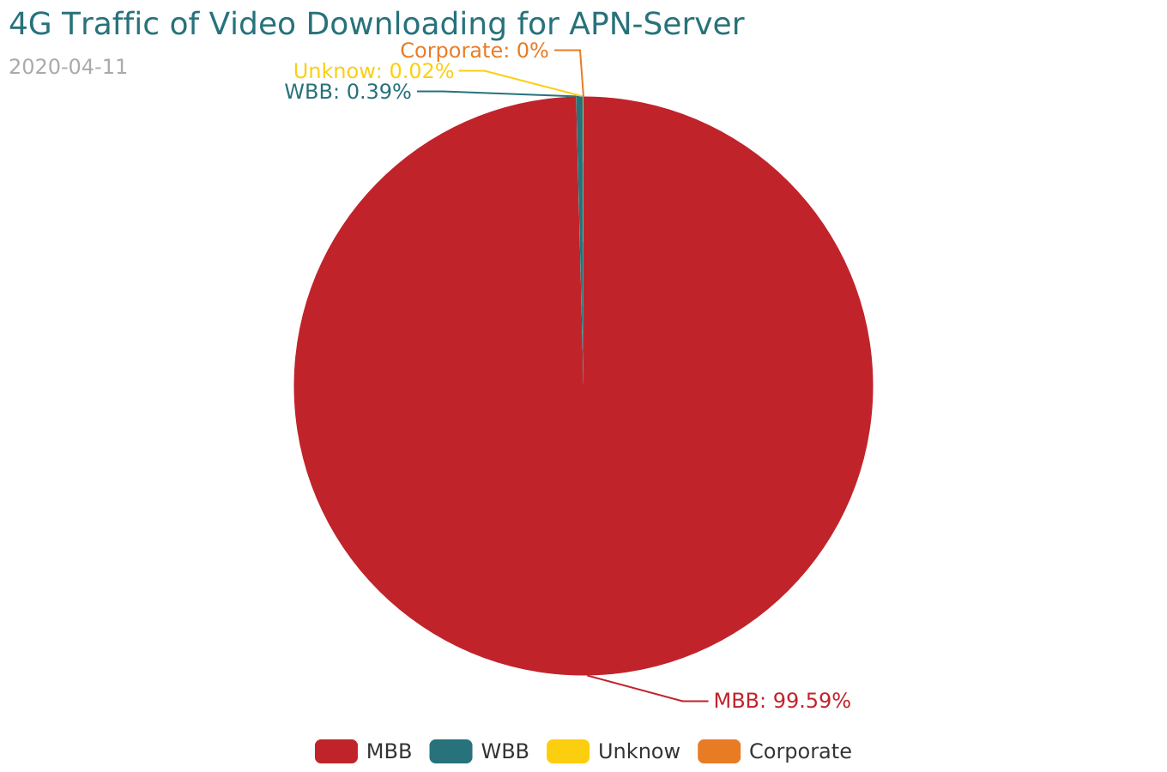

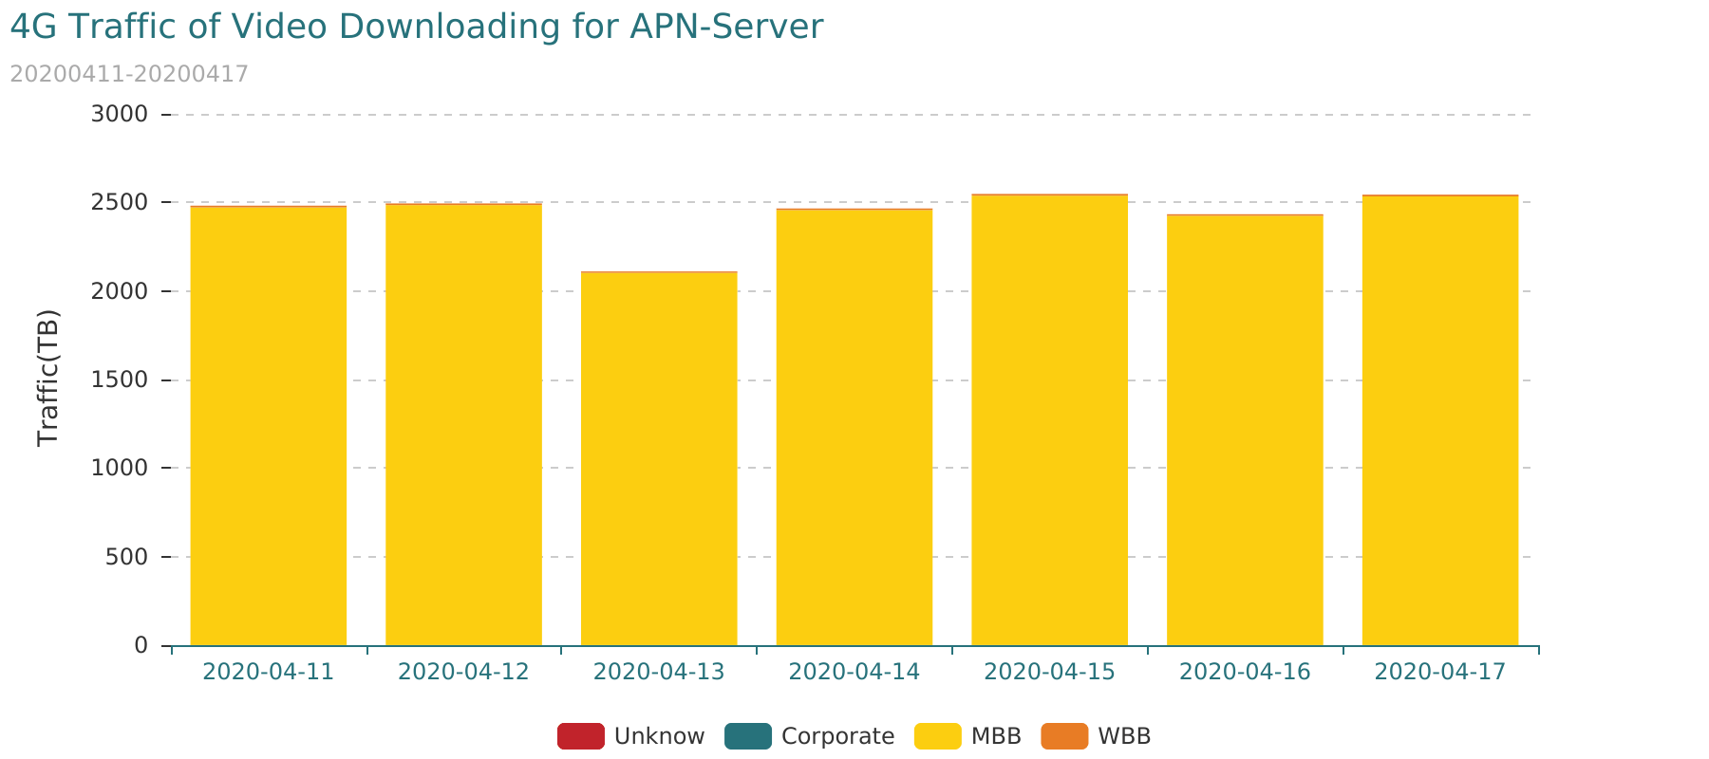

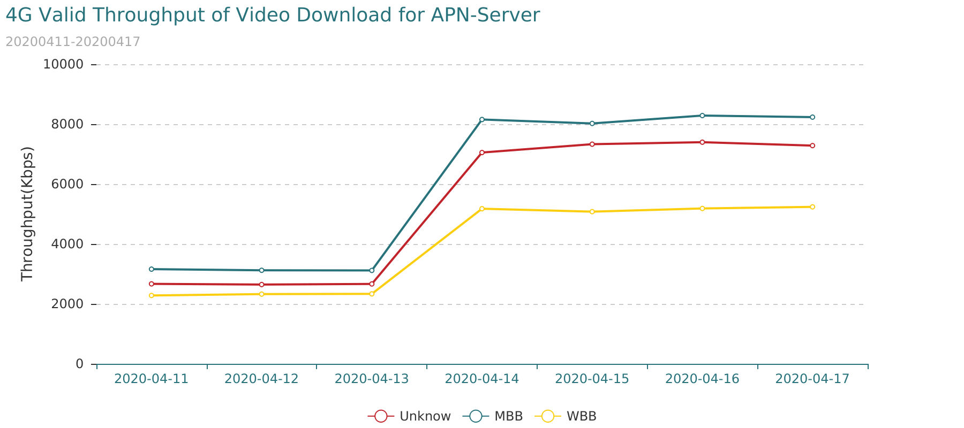

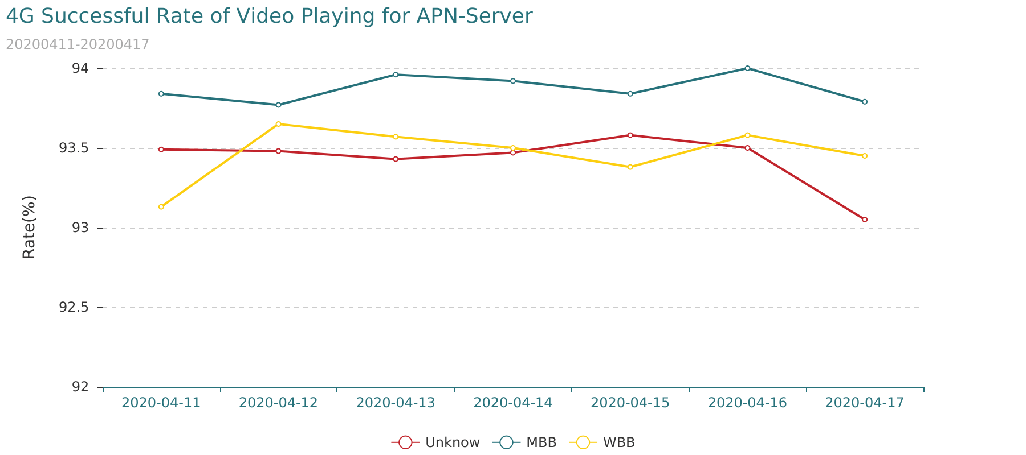

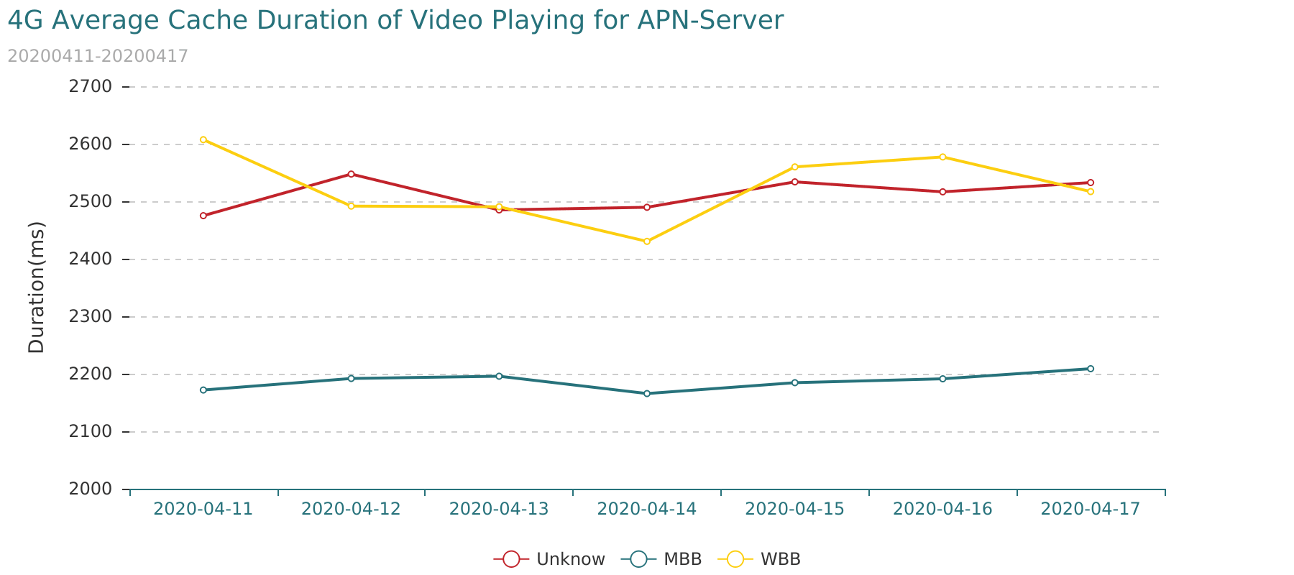

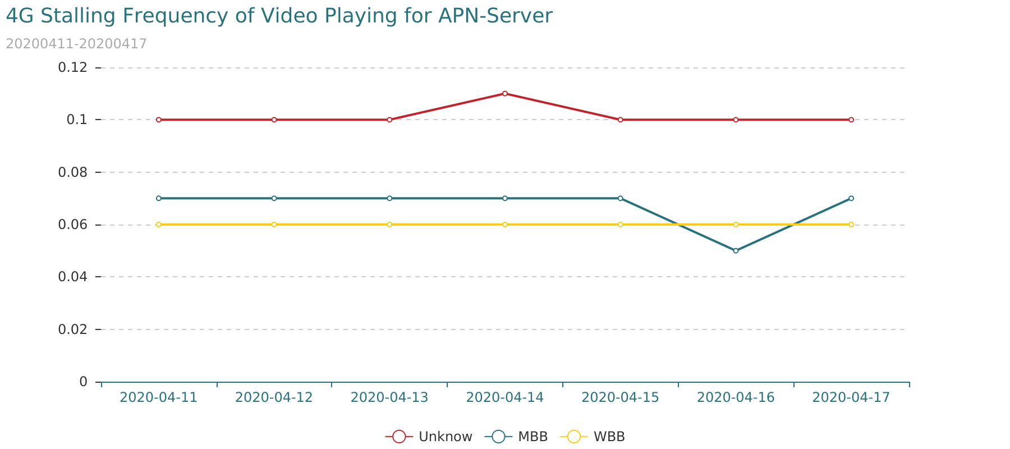

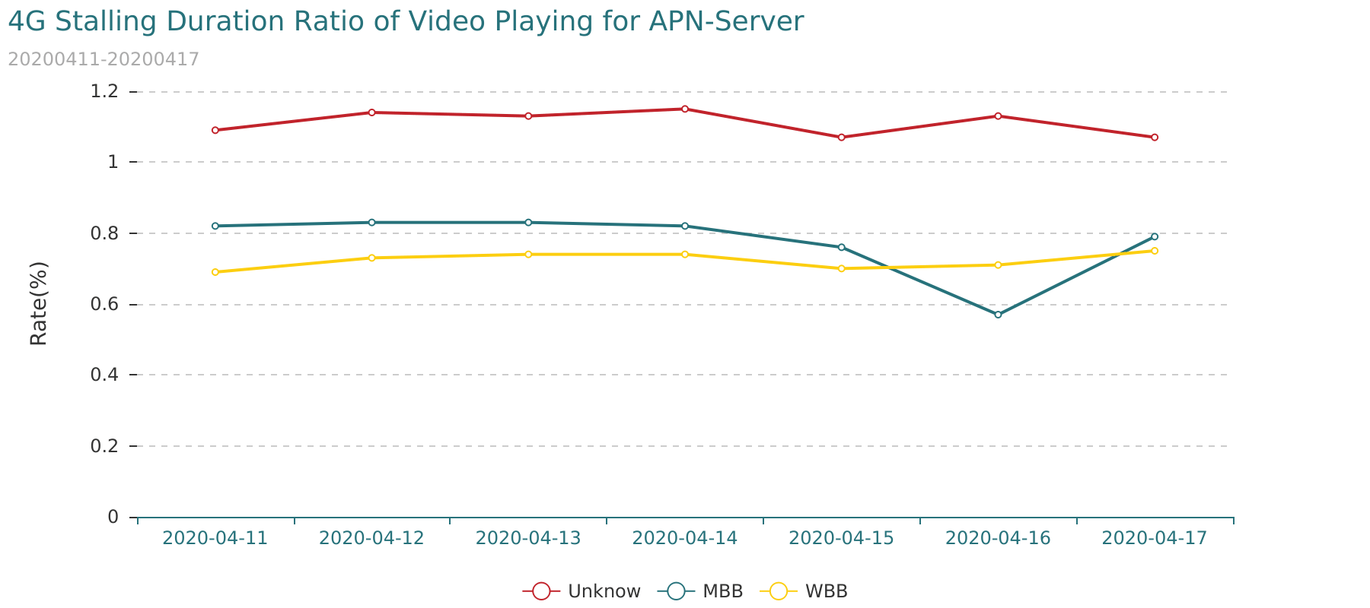

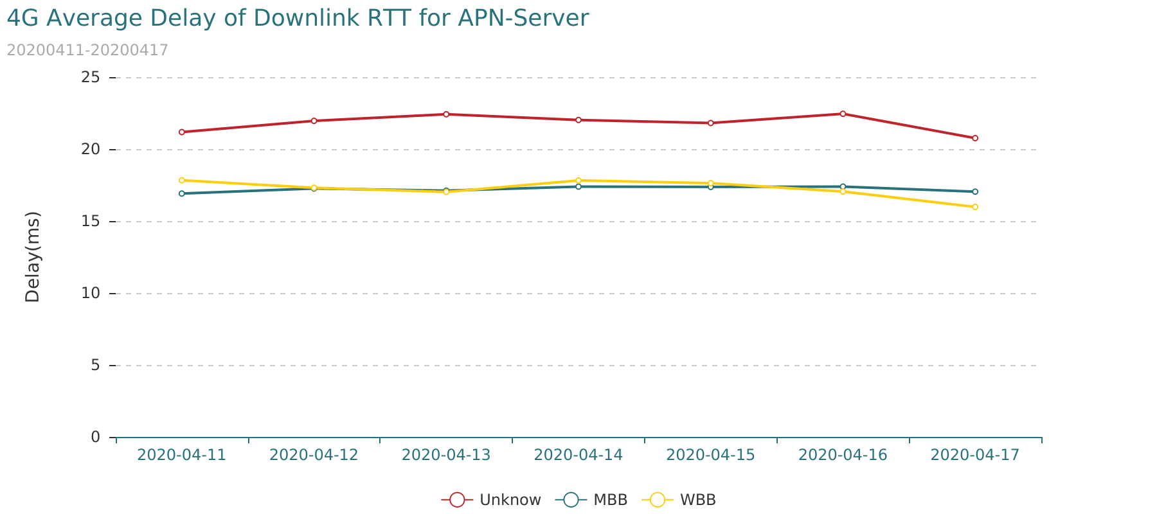

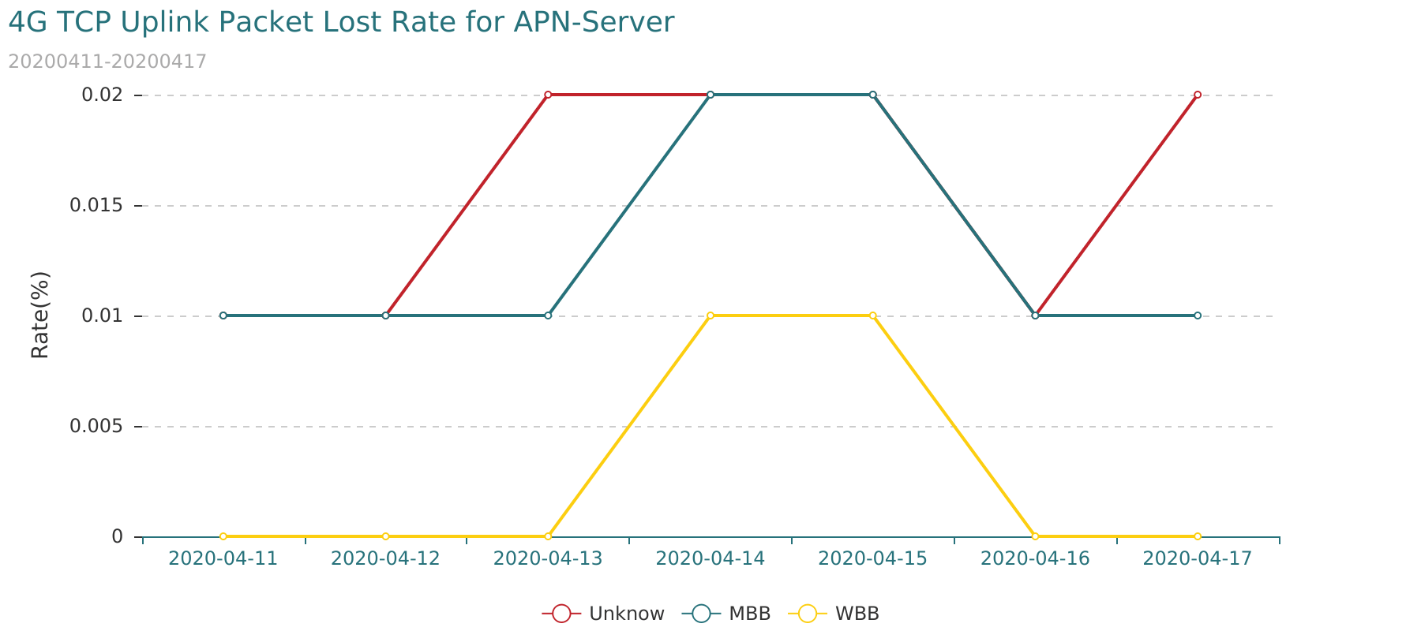

## 5.2 3G APN-Server Quality for Video Application

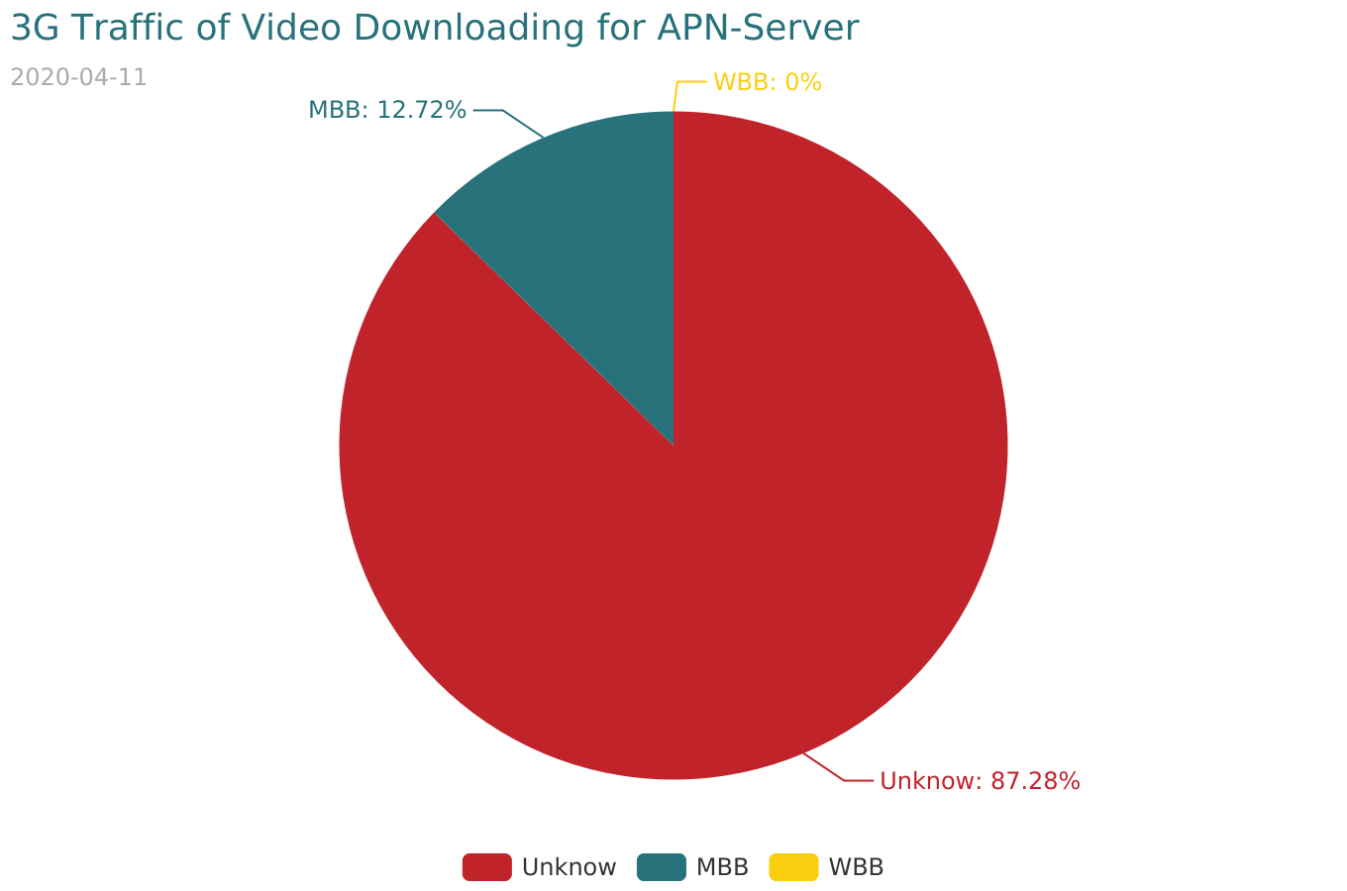

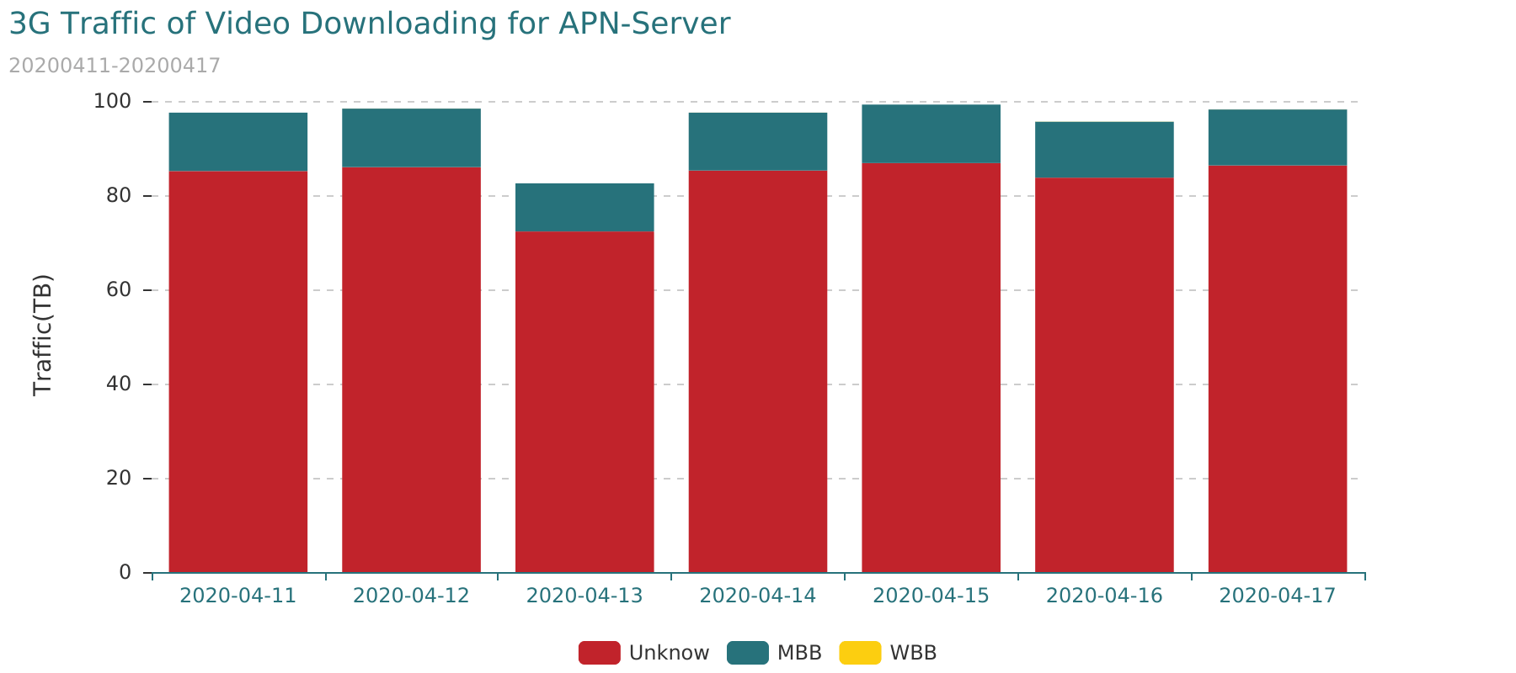

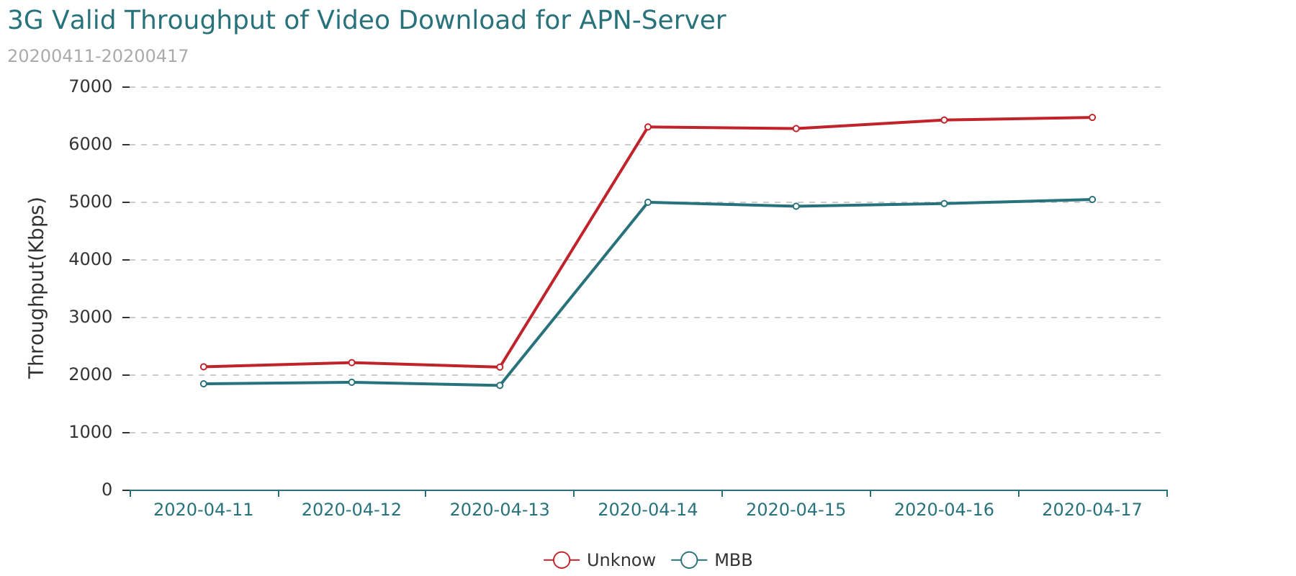

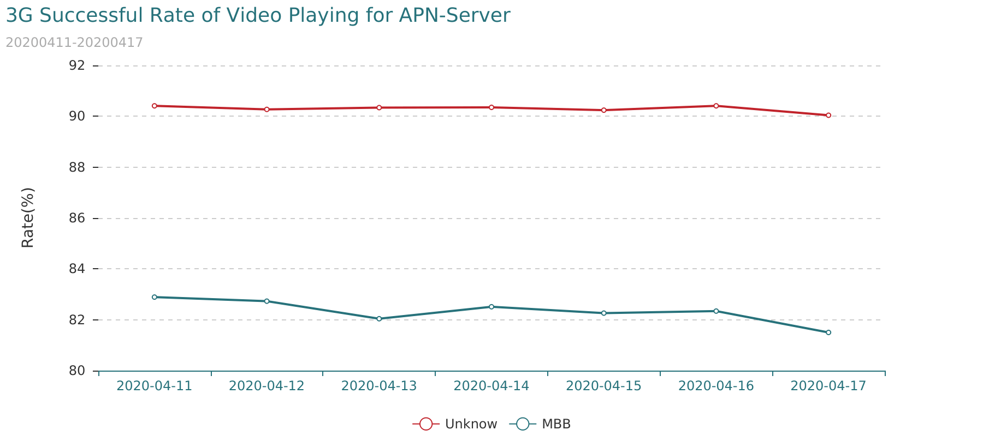

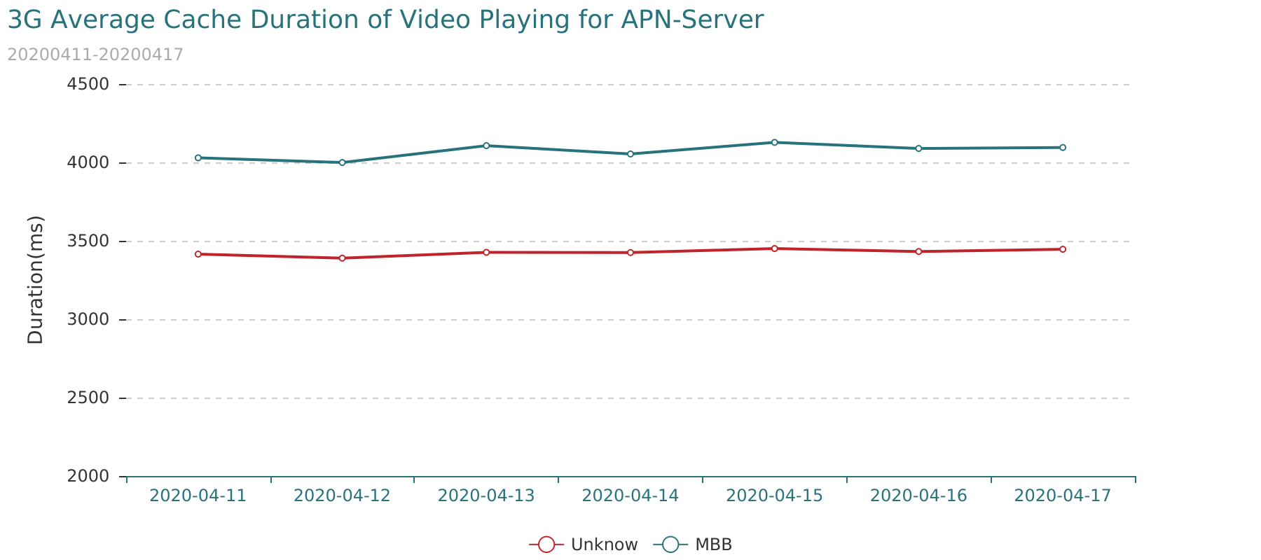

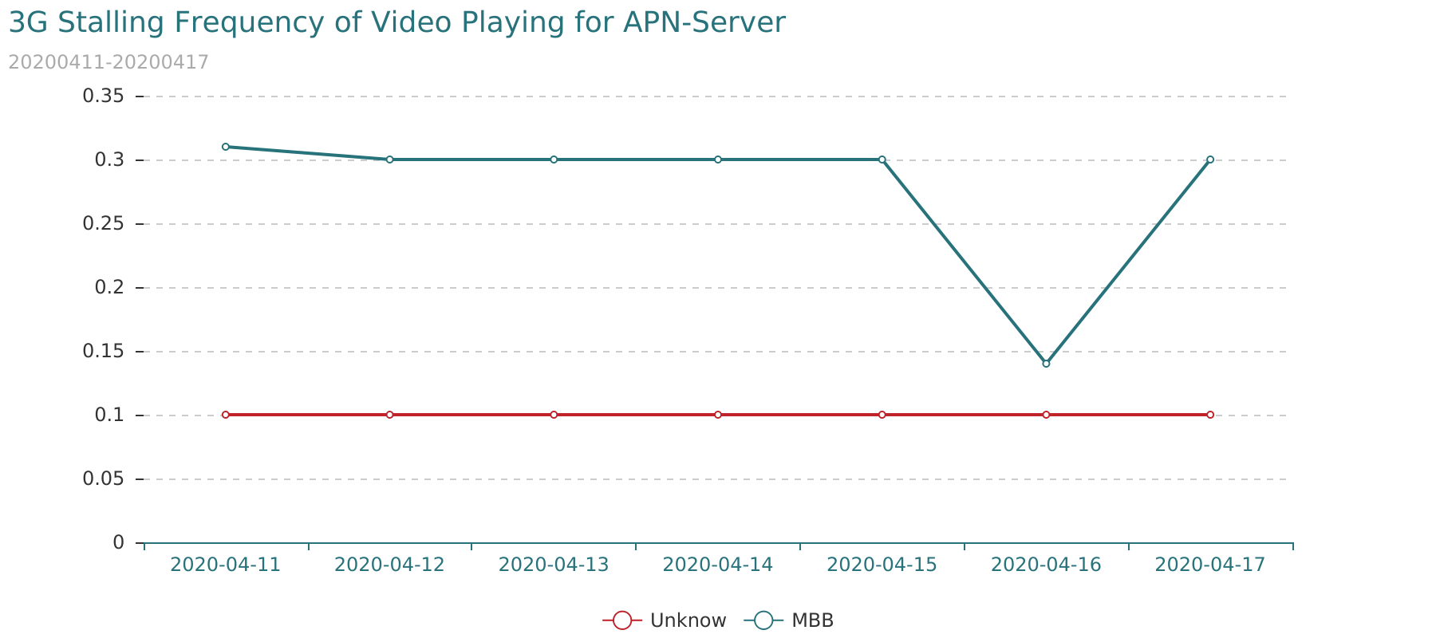

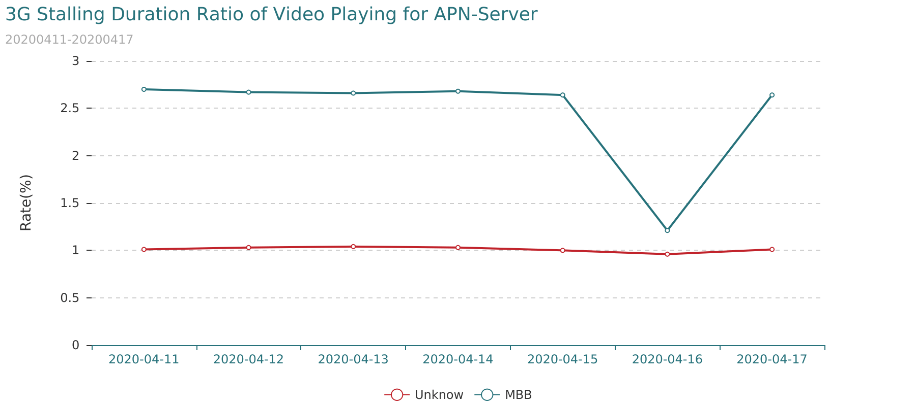

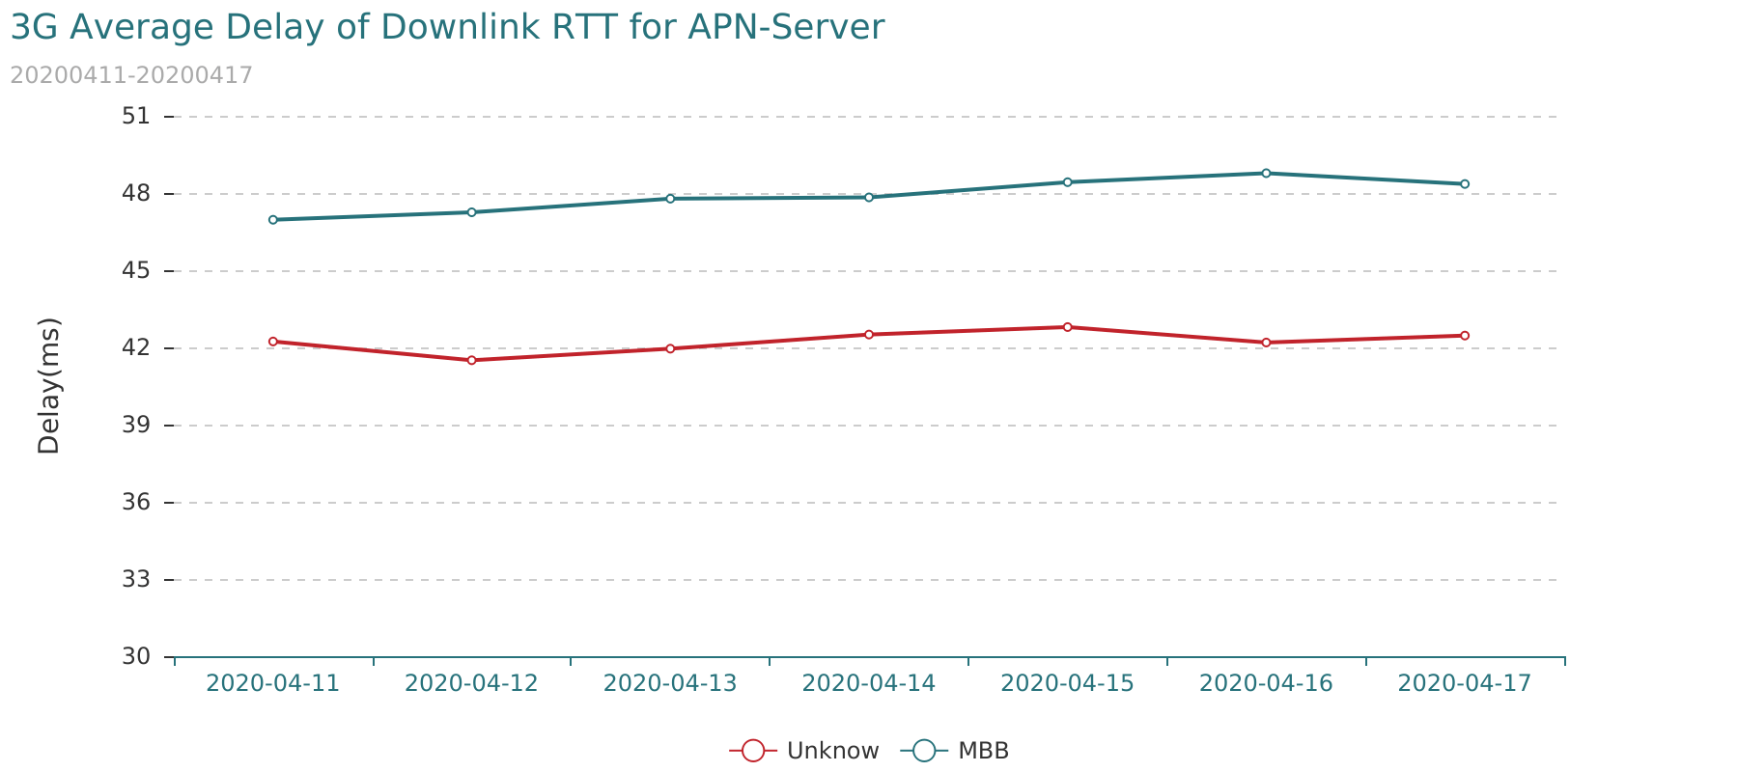

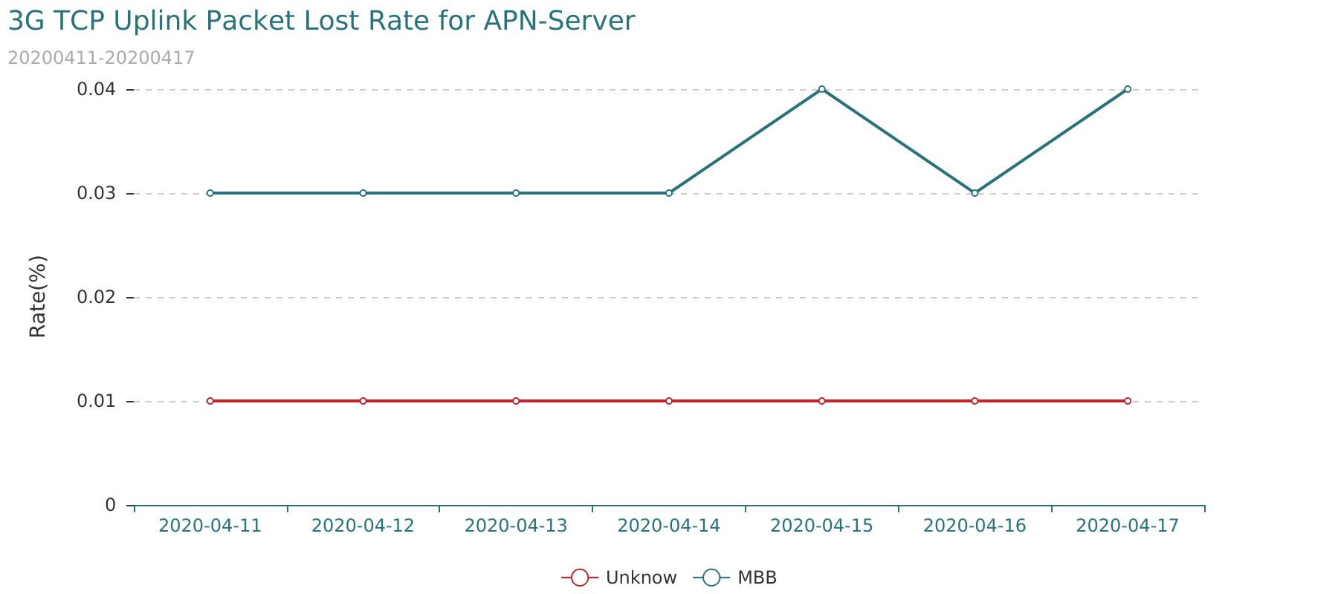

# 6 SGW Quality for Video Application

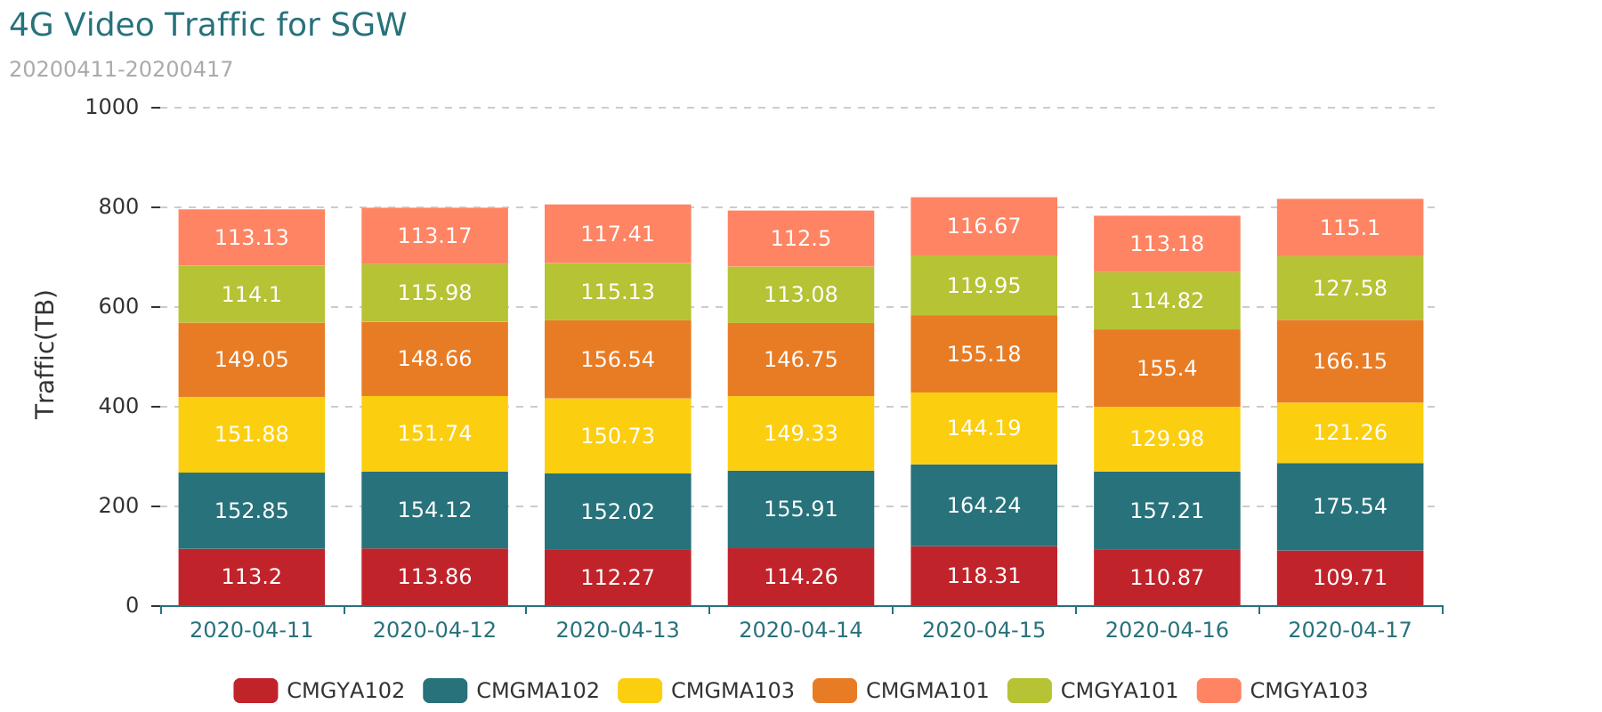

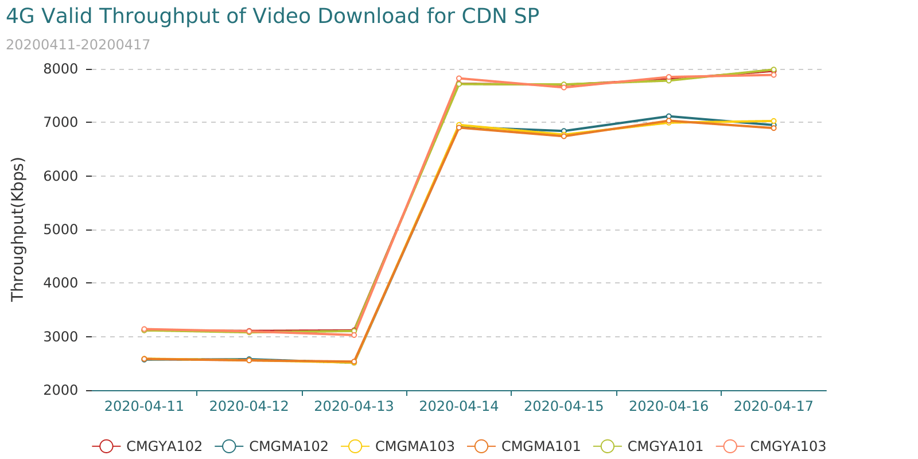

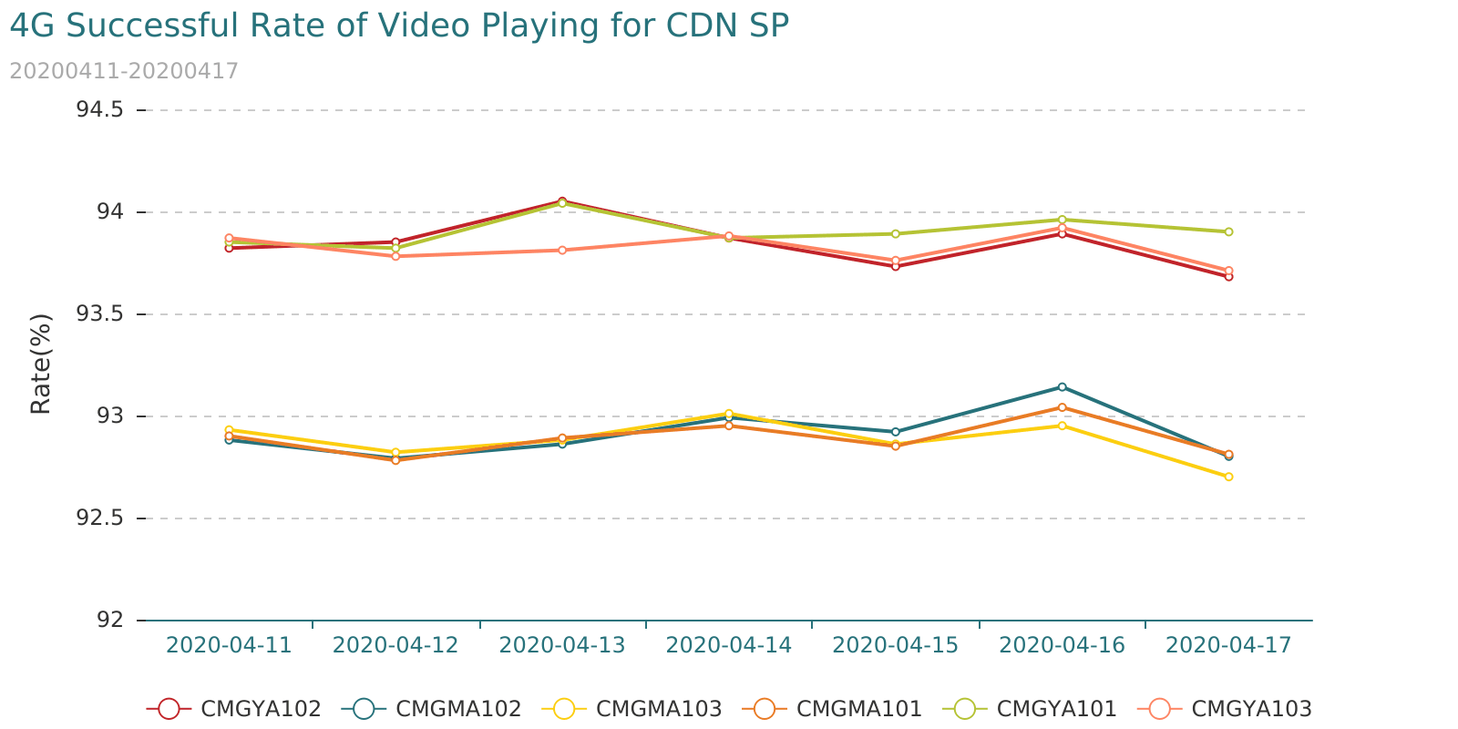

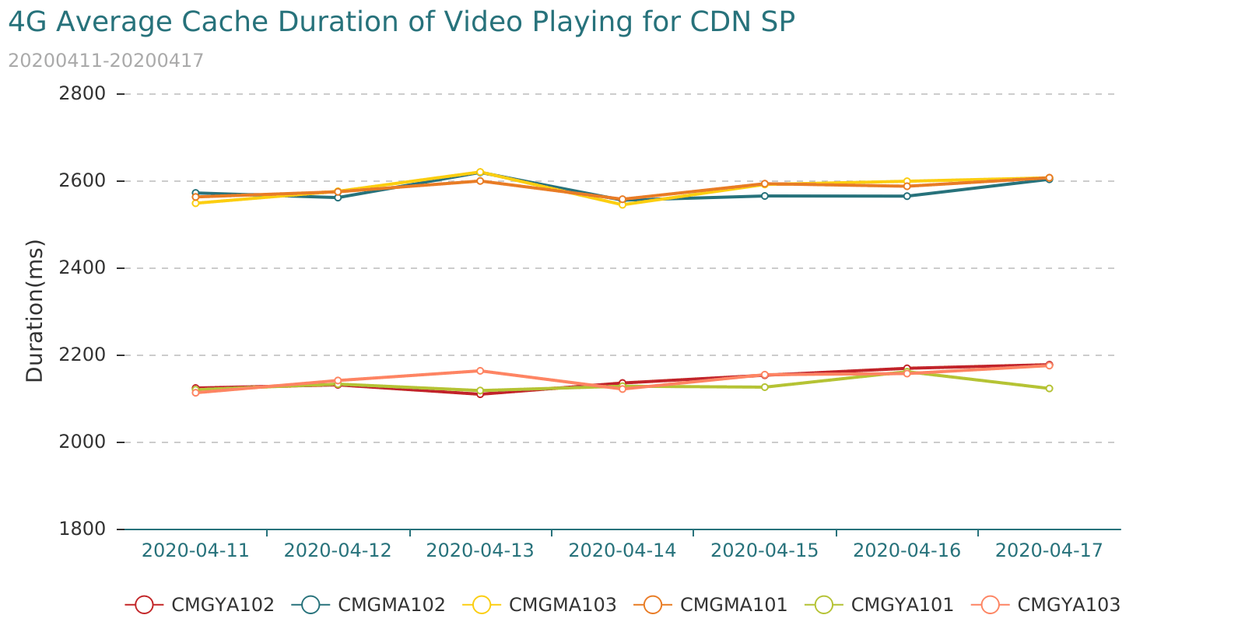

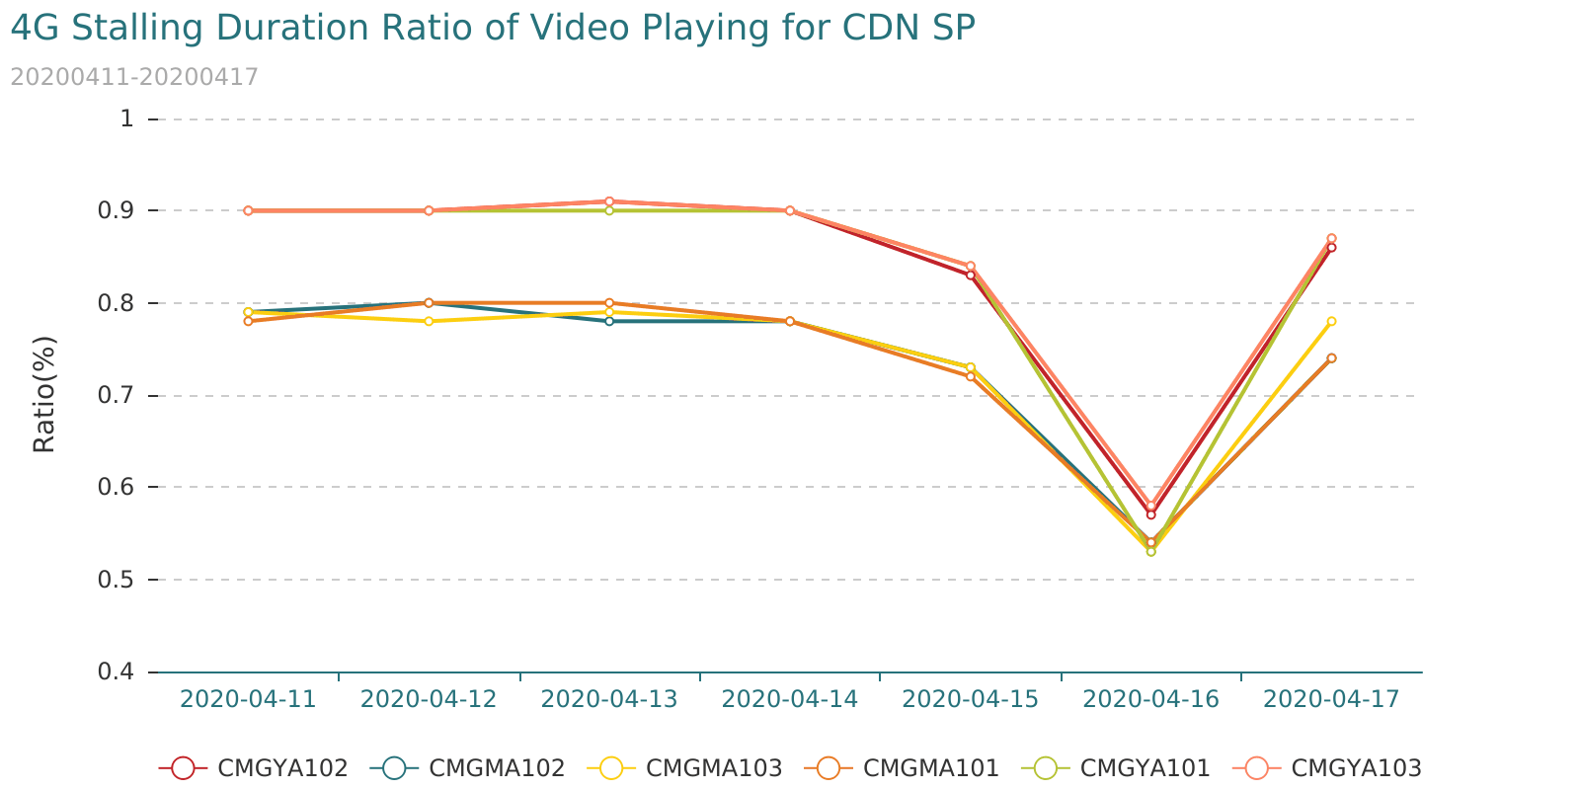

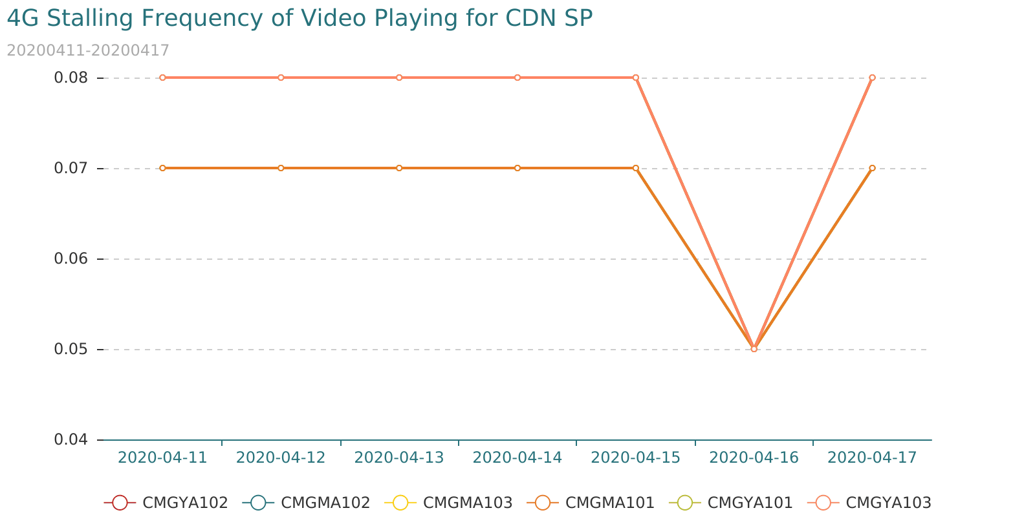

|  |  |  |
| --- | --- | --- |
| Date | CDN | Total Traffic(TB) |
| 2020-04-11 | 74.50.212.0/26 | 173.46 |
| 2020-04-11 | 43.224.84.64/26 | 315.91 |
| 2020-04-11 | 74.50.212.64/26 | 125.55 |
| 2020-04-11 | Other | 26.06 |
| 2020-04-11 | 43.224.84.0/26 | 158.85 |
| 2020-04-12 | 74.50.212.64/26 | 98.71 |
| 2020-04-12 | 43.224.84.64/26 | 349.64 |
| 2020-04-12 | Other | 26.34 |
| 2020-04-12 | 43.224.84.0/26 | 158.07 |
| 2020-04-12 | 74.50.212.0/26 | 171.52 |
| 2020-04-13 | 74.50.212.64/26 | 91.35 |
| 2020-04-13 | 43.224.84.64/26 | 355.29 |
| 2020-04-13 | Other | 26.16 |
| 2020-04-13 | 43.224.84.0/26 | 160.30 |
| 2020-04-13 | 74.50.212.0/26 | 174.28 |
| 2020-04-14 | 43.224.84.64/26 | 335.56 |
| 2020-04-14 | 74.50.212.64/26 | 94.31 |
| 2020-04-14 | Other | 26.70 |
| 2020-04-14 | 43.224.84.0/26 | 161.72 |
| 2020-04-14 | 74.50.212.0/26 | 177.26 |
| 2020-04-15 | 43.224.84.64/26 | 349.48 |
| 2020-04-15 | 74.50.212.64/26 | 96.88 |
| 2020-04-15 | Other | 27.49 |
| 2020-04-15 | 43.224.84.0/26 | 166.24 |
| 2020-04-15 | 74.50.212.0/26 | 182.17 |
| 2020-04-16 | 43.224.84.64/26 | 332.21 |
| 2020-04-16 | 74.50.212.64/26 | 94.65 |
| 2020-04-16 | Other | 27.00 |
| 2020-04-16 | 43.224.84.0/26 | 158.70 |
| 2020-04-16 | 74.50.212.0/26 | 172.93 |
| 2020-04-17 | 74.50.212.64/26 | 97.53 |
| 2020-04-17 | 43.224.84.64/26 | 351.40 |
| 2020-04-17 | Other | 28.31 |
| 2020-04-17 | 43.224.84.0/26 | 162.20 |
| 2020-04-17 | 74.50.212.0/26 | 178.08 |

## 6.3 Poor Quality SP for Video Application

* Condition1

"Total Traffic(MB)" distribution information is as follows:

|  |  |  |  |  |  |  |
| --- | --- | --- | --- | --- | --- | --- |
| Indicator | MAX | MIN | Mode | Mean | Median | Standard |
| Total Traffic(MB) | 324025213.71 | 0.02 | 0.03 | 19310.46 | 4.48 | 1864218.58 |

|  |  |  |  |  |  |  |  |
| --- | --- | --- | --- | --- | --- | --- | --- |
| Indicator | 5th Percentile | 10th Percentile | 20th Percentile | 50th Percentile | 80th Percentile | 90th Percentile | 95th Percentile |
| Total Traffic(MB) | 0.04 | 0.06 | 0.15 | 4.48 | 88.22 | 395.41 | 1443.86 |

Threshold: "Total Traffic(MB)" > 512(MB)

* Condition2

Video indicator distribution information is as follows:

|  |  |  |  |  |  |  |
| --- | --- | --- | --- | --- | --- | --- |
| Indicator | MAX | MIN | Mode | Mean | Median | Standard |
| Successful Rate of Video Playing(%) | 100.00 | 0.00 | 100.00 | 94.5 | 98.85 | 11.81 |
| Average Cache Duration of Video Playing(ms) | 29968.00 | 0.00 | 0.00 | 3927.04 | 3054.45 | 2870.58 |
| Stalling Frequency of Video Playing | 3.60 | 0.00 | 0.00 | 0.33 | 0.23 | 0.34 |
| Stalling Duration Ratio of Video Playing(%) | 64.66 | 0.00 | 0.00 | 3.24 | 2.11 | 3.44 |
| Valid Throughput of Video Download(Kbps) | 167493.55 | 0.00 | 0.00 | 6825.49 | 5612.22 | 6141.08 |

|  |  |  |  |  |  |  |  |
| --- | --- | --- | --- | --- | --- | --- | --- |
| Indicator | 5th Percentile | 10th Percentile | 20th Percentile | 50th Percentile | 80th Percentile | 90th Percentile | 95th Percentile |
| Successful Rate of Video Playing(%) | 72.35 | 82.98 | 93.33 | 98.85 | 100.0 | 100.0 | 100.0 |
| Average Cache Duration of Video Playing(ms) | 929.62 | 1123.55 | 1547.43 | 3054.22 | 6143.97 | 7930.51 | 9294.11 |
| Stalling Frequency of Video Playing | 0.0 | 0.01 | 0.06 | 0.23 | 0.54 | 0.73 | 0.93 |
| Stalling Duration Ratio of Video Playing(%) | 0.0 | 0.04 | 0.59 | 2.11 | 5.98 | 7.19 | 8.71 |
| Valid Throughput of Video Download(Kbps) | 995.18 | 1884.95 | 3031.03 | 5612.18 | 9187.53 | 12017.81 | 16269.57 |

Threshold:

"Successful Rate of Video Playing(%)" < 83.0%

"Average Cache Duration of Video Playing(ms)" > 7931.0ms

"Stalling Frequency of Video Playing" > 0.73

"Stalling Duration Ratio of Video Playing(%)" > 7.19%

"Valid Throughput of Video Download(Kbps)" < 1885.0Kbps

* Condition3

Poor-quality server_ip appear more than 4 times in 7 days.

* Condition4

Poor-quality server_ip has more than 2 indicator is bad in total 5 Indicator for 7 days.

"7day Traffic Traffic(MB)" distribution information is as follows:

|  |  |
| --- | --- |
| country_name | number |
| China | 15 |
| France | 1 |
| Germany | 7 |
| Japan | 3 |
| Netherlands | 4 |
| Singapore | 6 |
| Thailand | 2 |
| U.S.A | 6 |



|  |  |  |
| --- | --- | --- |
| segment | number | 7day Traffic Traffic(MB) |
| 104.18.36.* | 1 | 4274.25 |
| 104.18.37.* | 1 | 3983.98 |
| 107.155.27.* | 2 | 21579.620000000003 |
| 139.5.108.* | 3 | 13208.05 |
| 139.99.123.* | 1 | 5374.73 |
| 139.99.62.* | 1 | 4223.57 |
| 150.109.206.* | 3 | 36016.590000000004 |
| 151.101.10.* | 1 | 55222.34 |
| 172.81.120.* | 8 | 391854.19999999995 |
| 192.254.94.* | 3 | 25038.04 |
| 23.236.102.* | 3 | 11587.68 |
| 45.113.131.* | 1 | 28246.93 |
| 54.192.151.* | 3 | 51542.530000000006 |
| 63.251.239.* | 1 | 4109.92 |
| 79.137.64.* | 1 | 5208.75 |
| 89.255.248.* | 4 | 13861.25 |
| 89.255.250.* | 7 | 96667.7 |

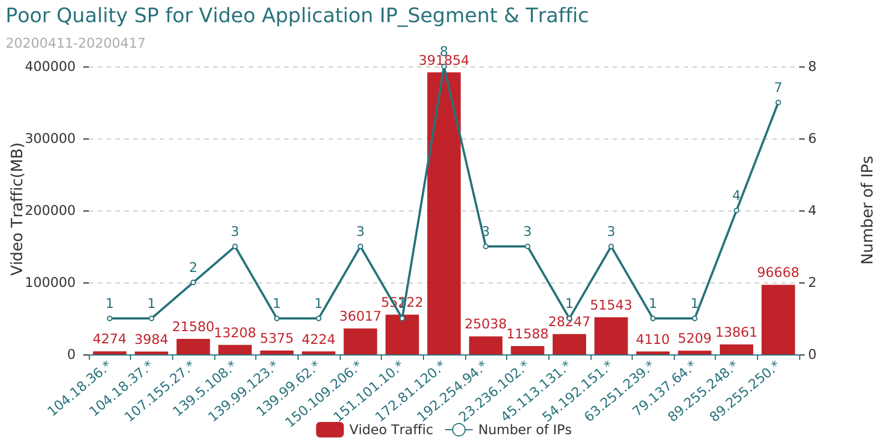

The poor-quality SP for attachment<Poor_Quality_SP_for_Video_Application.xlsx>

## 6.4 Poor Quality CDN SP for FACEBOOK-Video Application

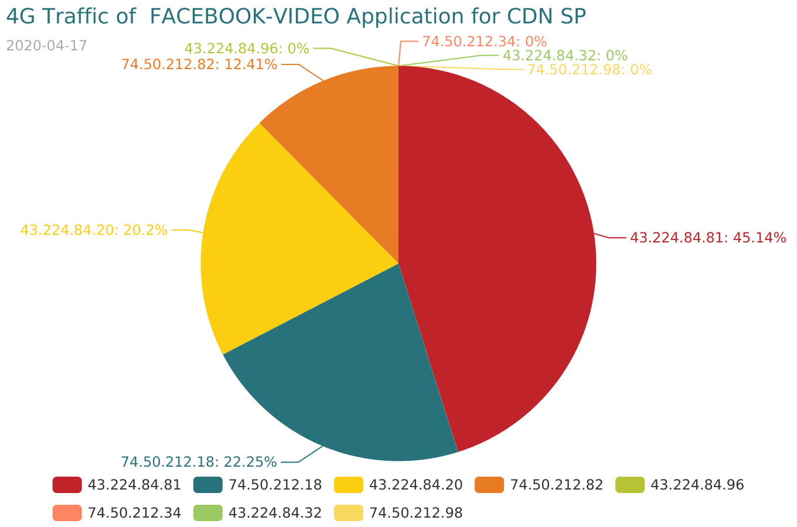



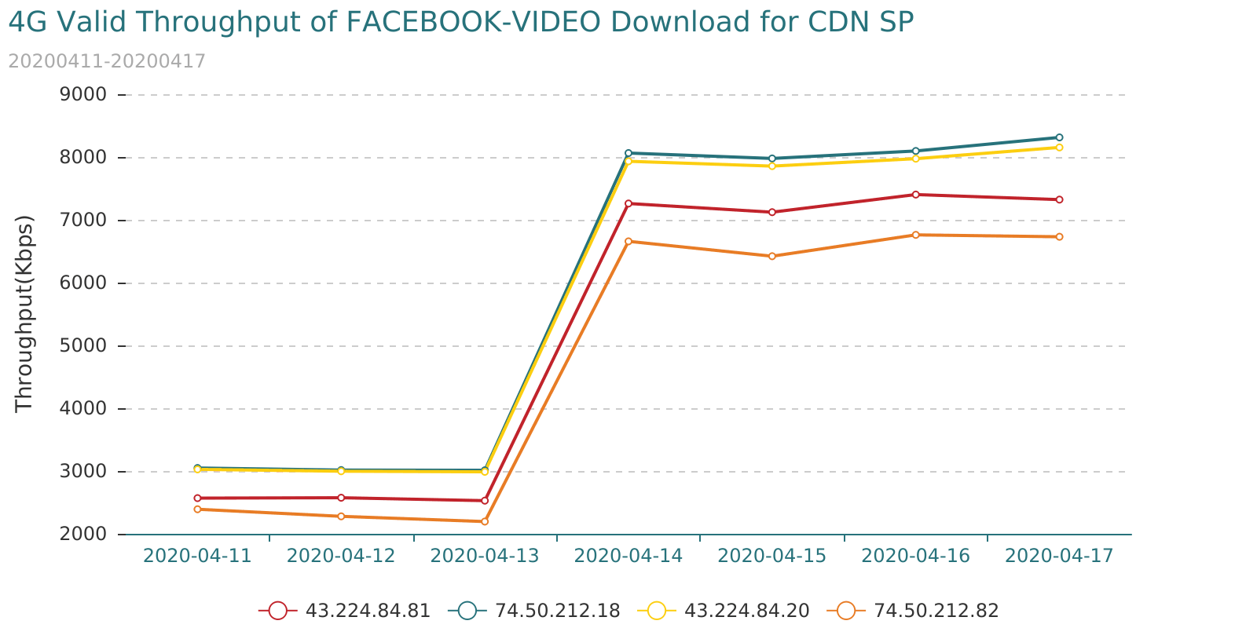

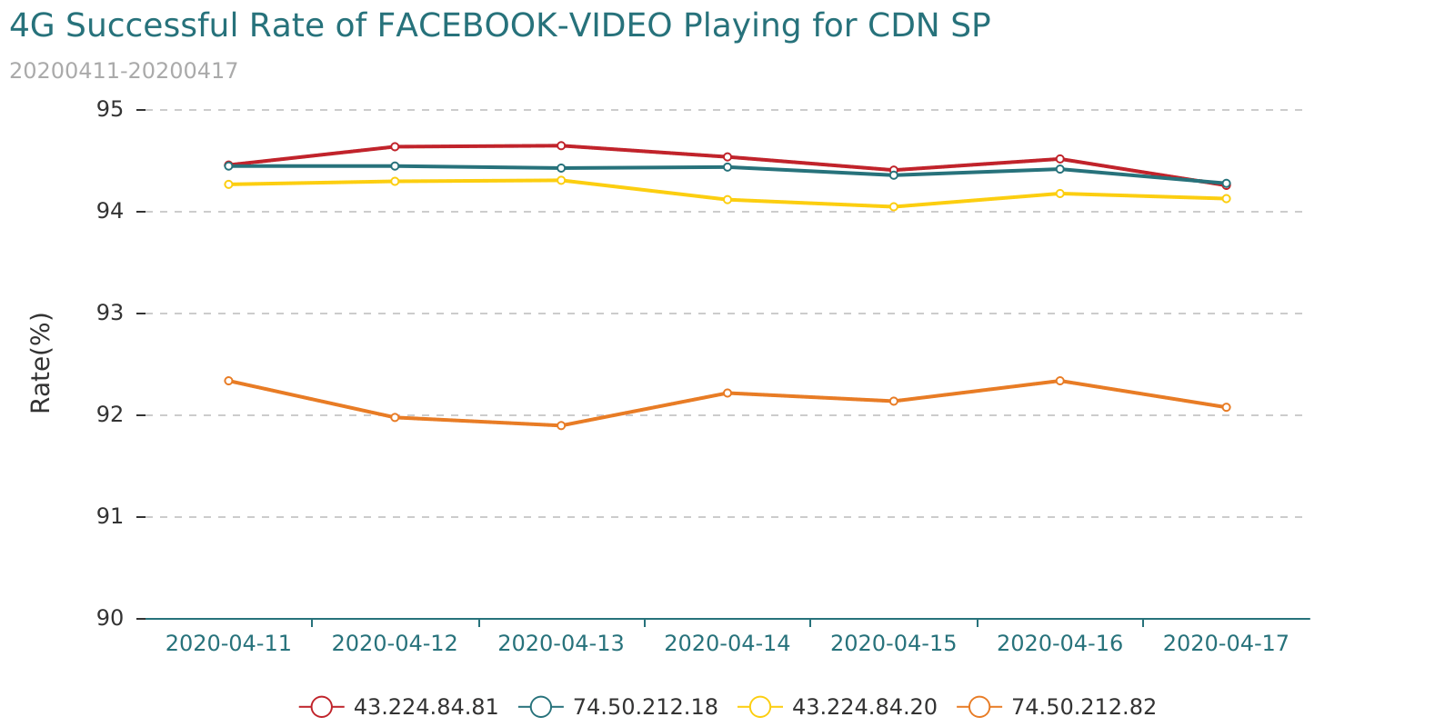

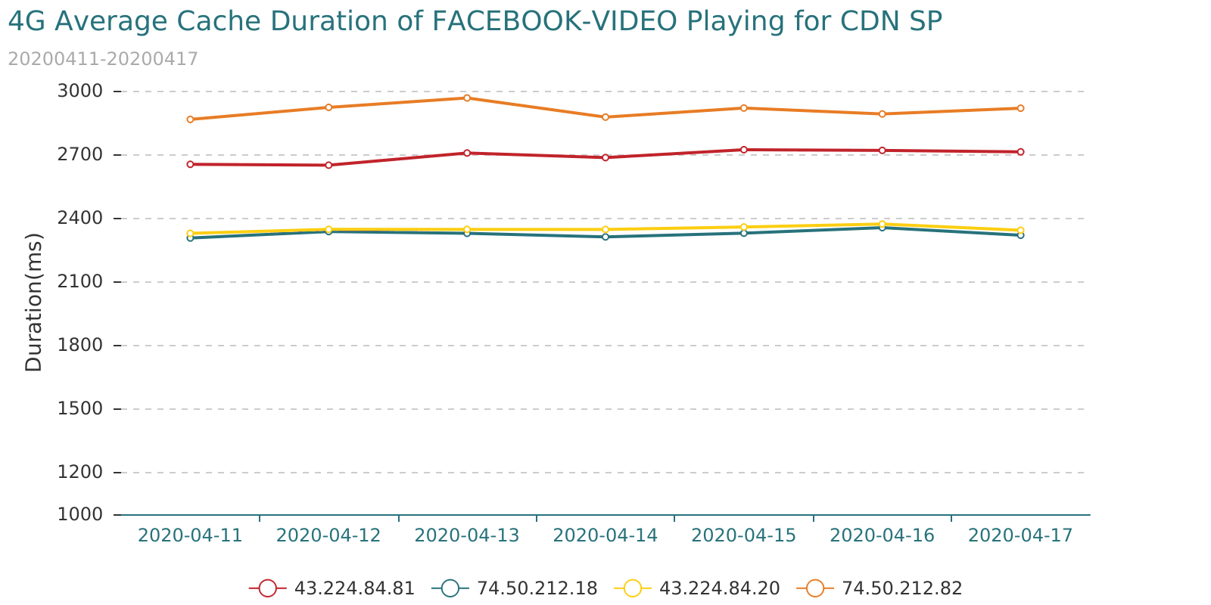

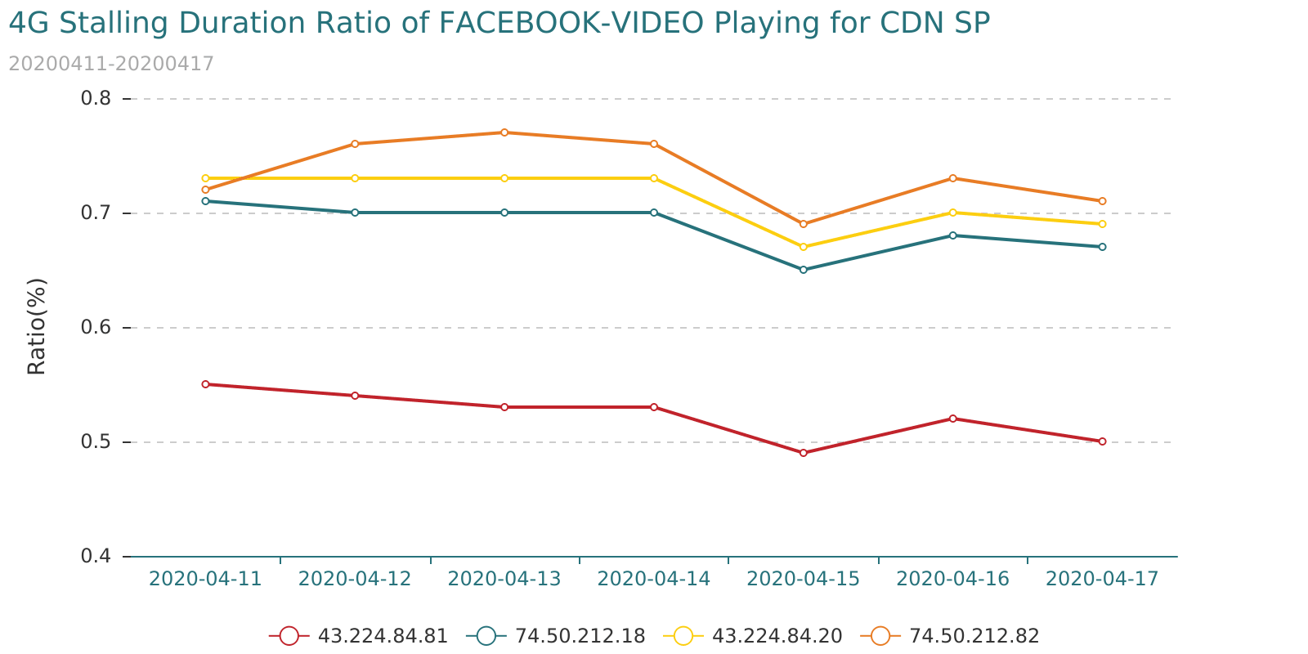

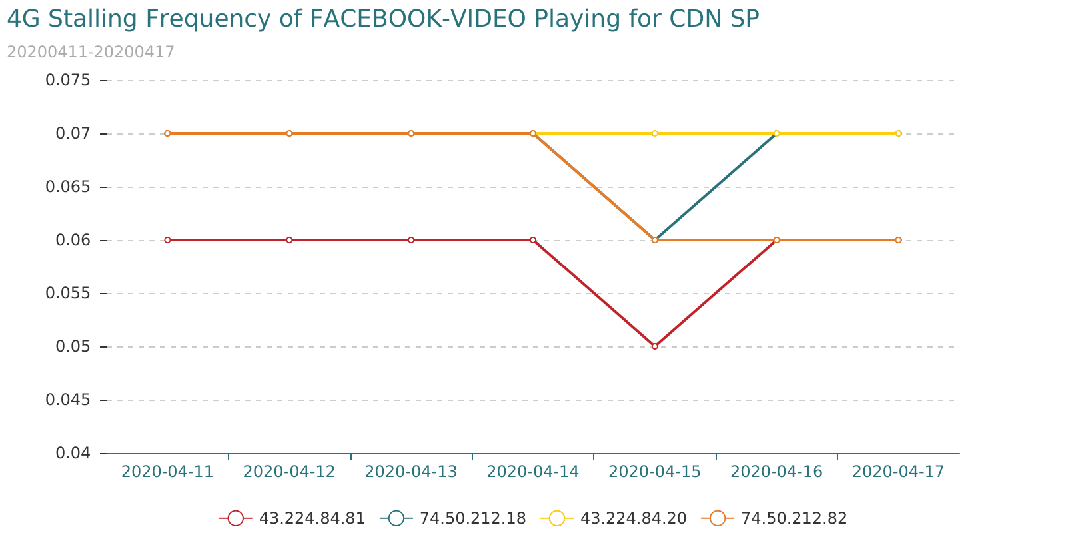

## 6.5 Poor Quality Non-CDN SP for FACEBOOK-Video Application

* Condition1

"Total Traffic(MB)" distribution information is as follows:

|  |  |  |  |  |  |  |
| --- | --- | --- | --- | --- | --- | --- |
| Indicator | MAX | MIN | Mode | Mean | Median | Standard |
| Total Traffic(MB) | 20294166.54 | 0.02 | 0.07 | 27282.67 | 11.21 | 540329.37 |

|  |  |  |  |  |  |  |  |
| --- | --- | --- | --- | --- | --- | --- | --- |
| Indicator | 5th Percentile | 10th Percentile | 20th Percentile | 50th Percentile | 80th Percentile | 90th Percentile | 95th Percentile |
| Total Traffic(MB) | 0.13 | 0.38 | 1.24 | 11.21 | 134.02 | 455.65 | 2112.44 |

Threshold: "Total Traffic(MB)" > 100(MB)

* Condition2

Video indicator distribution information is as follows:

|  |  |  |  |  |  |  |
| --- | --- | --- | --- | --- | --- | --- |
| Indicator | MAX | MIN | Mode | Mean | Median | Standard |
| Successful Rate of Video Playing(%) | 100.00 | 0.00 | 100.00 | 84.17 | 85.25 | 10.16 |
| Average Cache Duration of Video Playing(ms) | 26205.00 | 0.00 | 0.00 | 3221.5 | 3314.41 | 1657.67 |
| Stalling Frequency of Video Playing | 1.96 | 0.00 | 0.00 | 0.09 | 0.07 | 0.11 |
| Stalling Duration Ratio of Video Playing(%) | 14.20 | 0.00 | 0.00 | 1.09 | 0.8 | 1.18 |
| Valid Throughput of Video Download(Kbps) | 48020.31 | 0.00 | 1365.31 | 5008.57 | 4449.77 | 4200.19 |

|  |  |  |  |  |  |  |  |
| --- | --- | --- | --- | --- | --- | --- | --- |
| Indicator | 5th Percentile | 10th Percentile | 20th Percentile | 50th Percentile | 80th Percentile | 90th Percentile | 95th Percentile |
| Successful Rate of Video Playing(%) | 65.03 | 70.9 | 76.03 | 85.25 | 91.43 | 100.0 | 100.0 |
| Average Cache Duration of Video Playing(ms) | 414.5 | 1287.16 | 1857.74 | 3310.94 | 4356.64 | 4762.78 | 5187.21 |
| Stalling Frequency of Video Playing | 0.0 | 0.0 | 0.03 | 0.07 | 0.12 | 0.15 | 0.21 |
| Stalling Duration Ratio of Video Playing(%) | 0.0 | 0.02 | 0.37 | 0.8 | 1.52 | 2.32 | 3.32 |
| Valid Throughput of Video Download(Kbps) | 1300.59 | 1494.7 | 1920.86 | 4449.48 | 6454.07 | 8436.28 | 11849.12 |

Threshold:

"Successful Rate of Video Playing(%)" < 71.0%

"Average Cache Duration of Video Playing(ms)" > 4763.0ms

"Stalling Frequency of Video Playing" > 0.15

"Stalling Duration Ratio of Video Playing(%)" > 2.32%

"Valid Throughput of Video Download(Kbps)" < 1495.0Kbps

* Condition3

Poor-quality server_ip appear more than 4 times in 7 days.

* Condition4

Poor-quality server_ip has more than 1 indicator is bad in total 5 Indicator for 7 days.

"7day Traffic Traffic(MB)" distribution information is as follows:

|  |  |
| --- | --- |
| country_name | number |
| China | 1 |
| Nepal | 1 |
| The United Arab Emirates | 4 |
| U.S.A | 5 |
| Vietnam? | 4 |



|  |  |  |
| --- | --- | --- |
| segment | number | 7day Traffic Traffic(MB) |
| 120.89.99.* | 1 | 1062.32 |
| 157.240.11.* | 1 | 59493.95 |
| 157.240.15.* | 1 | 2654.19 |
| 157.240.162.* | 4 | 14035.98 |
| 157.240.218.* | 1 | 1279.81 |
| 157.240.220.* | 1 | 5743.37 |
| 157.240.23.* | 1 | 1957.99 |
| 183.80.129.* | 1 | 4435.94 |
| 183.80.211.* | 1 | 4420.45 |
| 31.13.70.* | 1 | 172587.7 |
| 42.118.90.* | 1 | 3713.07 |
| 45.126.99.* | 1 | 1098.53 |

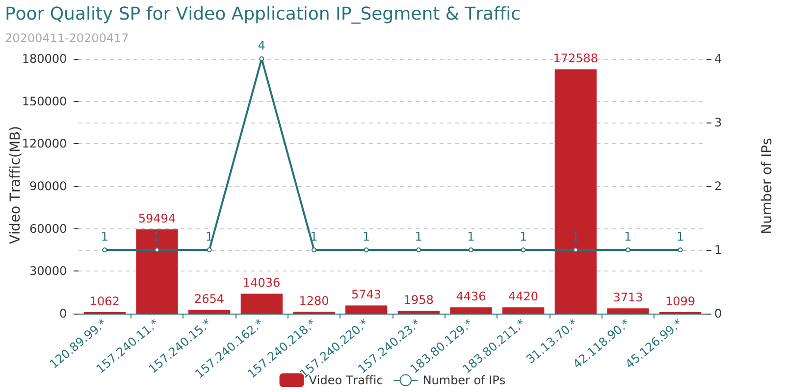

The poor-quality SP for attachment<Poor_Quality_SP_for_FACEBOOK-VIDEO_Application.xlsx>